Table Of Contents
INTRODUCTION 1
About Organization 1
ABOUT US 2
About Project 2
PROBLEM DEFINITION 3
Existing System: 3
Proposed System: 3
DESIGN DOCUMENT 4
System Design: 4
Database Design: 5
SYSTEM ANALASYS 8
Dataflow Diagrams 8
Context Level Diagram 12
E – R Diagrams 19
UML Diagrams 23
Modules 30
Module Description 30
Content Management: 31
Feasibility Analysis 32
SOFTWARE REQUIREMENT SPECIFICATION 34
What is SRS? 34
Role Of Srs: 34
ABOUT SOFTWARE 36
Overview Of Java Technology 36
Java Architecture 37
An Overview of JSP 38
The Java Server Pages™ Technology 38
About HTML 40
Introduction to Servlets 40
Architecture of the Servlet Package 40
Initialization Parameters 40
Sample Code: 40
TESTING 40
SCREENS AND FORMS 40
CONCLUSION

Books Referred 40
Web Sites Referred 40

INTRODUCTION

About Organization

ABOUT US

Abstraction
In order for a needs assessment to have a successful outcome, it must accomplish many things--improving performance being just one. It must also
- determine how to achieve the high-level goals of the organization (such as increasing sales and fostering innovation)
- determine what system obstacles (other than training) need to be removed
- point to an intervention that will balance the conflicting needs of different stakeholders (IT versus HR, participants versus managers, budget versus vendor costs, and so on)
- Pave the way for a new program.
Organizations implementing Knowledge Storm programs need to expand the usual needs assessment process by creating a high-level requirements document that includes
- objectives (macro organizational objectives and micro target learner population objectives)
- a KnowledgeStorm readiness score
- a list of advantages and potential obstacles to KnowledgeStorm adoption
- a list of possible KnowledgeStorm configurations.

PROBLEM DEFINITION

Existing System:

There is no online Education facility in many educational institutions . Till now they used normal system of education . Because of this type of education many people may suffer due to distance problem and money problem.In this system it may take more time to conduct exams and to give results.

Proposed System:
To overcome the problems in existing education system we are developing this system. With this system people can learn from their own cities and villages easily. By using this system they can conduct exams and give results in online within short period of time.

DESIGN DOCUMENT

System Design:

SOFTWARE REQUIREMENTS:

- J2SDK1.5 (Servlets)
- JSP(Java Server Page)
- JDBC Drivers installed
- Fully Functional Html Editor
- Apache Tomact
- Database ( oracle or Sql server)

HARDWARE REQUIREMENTS

- Personal computer with 80486 or higher processor
- 20 GB hard disk space
- 128 MB RAM

Database Design:

User_details:

Column Name | Type(size) | Constraint
UserName | Varchar2(20) | Not null
PassWord | Varchar2(20)
FirstName | Varchar2(20) | Not null
MidName | Varchar2(6)
LastName | Varchar2(10)
Suffix | Varchar2(6)
Address | Varchar2(30)
Gender | Varchar2(6)
Email | Varchar2(30) | Not null
City | Varchar2(1)
State | Varchar2(12)
Country | Varchar2(12)
Zipcode | Number(9)
PhNo | Number(10)
Job | Varchar2(15)
Webaddr | Varchar2(20)

Admin:

Column name | Type(size) | Constraint
UserName | Varchar2(20) | Not null
PassWord | Varchar2(20) | Not null

Courses:

Column name | Type(size) | Constraint
Course_id | Varchar2(10) | Primary key
Course_cat | Varchar2(20)
Course_name | Varchar2(20) | Not null
No_of_sessions | Number(2) | Not null

Course_details:

Column name | Type(size) | Constraint
UserName | Varchar2(20) | References user_details(userName)
Course_id | Varchar2(10) | References Courses(course_id)
Session_no | Number(2)

Session_details:

Column name | Type(size) | Constraint
Course_id | Varchar2(10) | References Courses(course_id)
Session_no | Varchar2(10)
Filename | Varchar2(15)

Question_Answer:

Column name | Type(size) | Constraint
Question_id | Number(4) | Primary key
Course_id | Varchar2(10) | References Courses(course_id)
Question_desc | Varchar2(50)
Option1 | Varchar2(30)
Option2 | Varchar2(30)
Option3 | Varchar2(30)
Option4 | Varchar2(30)
Answer | Varchar2(10)

Results_master:

Column name | Type(size) | Constraint
User_name | Varchar2(20) | References User_details(UserName)
Course _id | Varchar2(10) | References Courses(Course_id)
Percentage | Number(3)

SYSTEM ANALASYS

Dataflow Diagrams

Dataflow Diagram is a structure analysis tool that is used for graphical representation of Data processes through any organization . the data flow approach emphasis on the logic underlying the system, by using combination of only 4 symbols. It follows a top down approach. A full description of a system actually consists of set of DFD s , which comprises of various levels. And initial over view model is exploded lower level diagrams that show additional feature of the system. Further each process can be broken down into a more detailed DFD. This occurs repeatedly until sufficient details is described.

DFD symbols
Square

it defines a source (originator ) or destination of system data.

Arrow

It indicates data flow-data in motion. It is a pipeline through which information flows.

Circle or Bubble

It represents a process that transforms incoming data flow(s) into outgoing data flow(s).

Open Rectangle

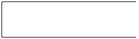

it is a data store-data at rest, or a temporary repository of data. Here I am giving only the Data Flow Diagram.

They are explained by
- GANE and SARON method
- DEMACRO YORDAN method

GANE AND SARSON NOTATION

DATA FLOW

DATA STRUCTURE

EXTERNAL ENTITY
OR DATA LINK

PROCESS

DATA BASE

DEMACRO YORDAN NOTATION

DATA FLOW

DATA STRUCTURE

EXTERNAL ENTITY
OR DATA LINK

PROCESS

DATA BASE 

E-R Diagrams

Context Level Diagram

Request
Knowledge Storm
STUDENT
Request
STUDENT

Request
Request
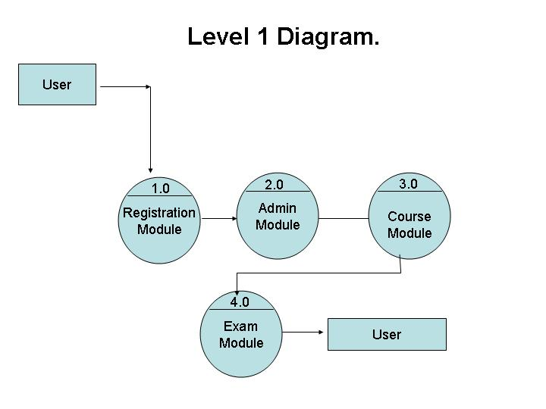

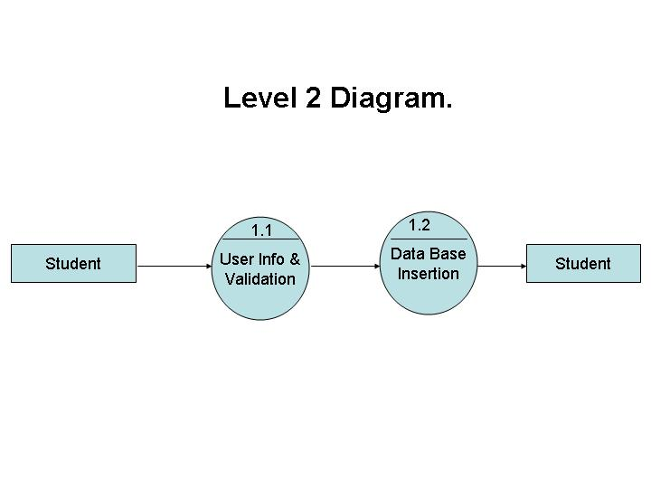

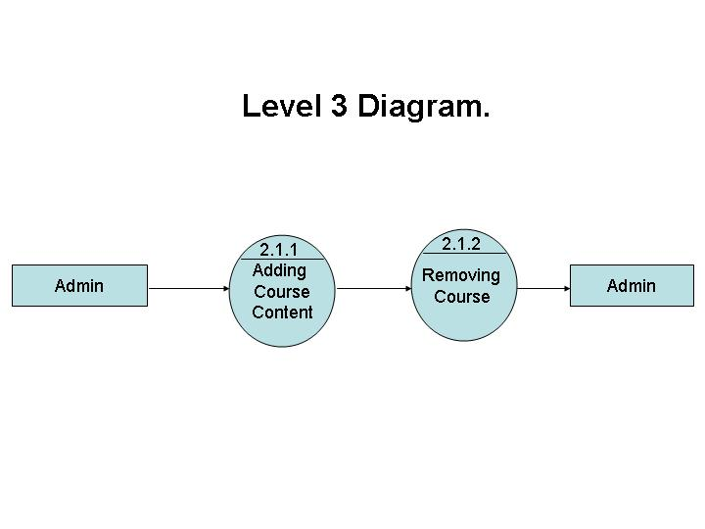

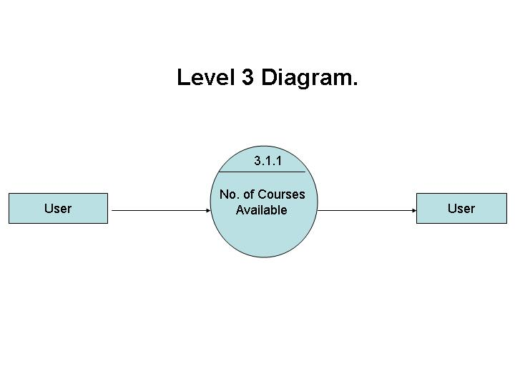

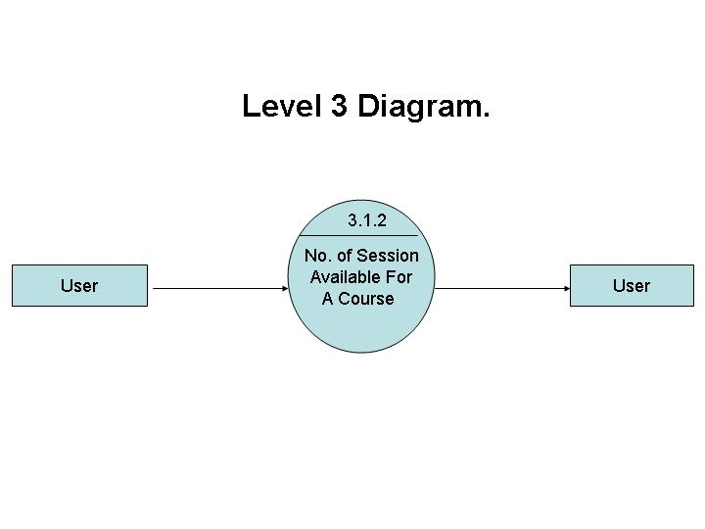

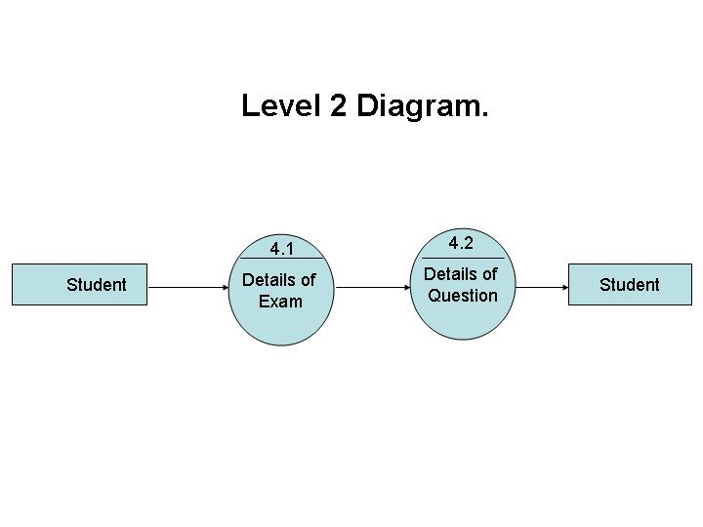

E – R Diagrams

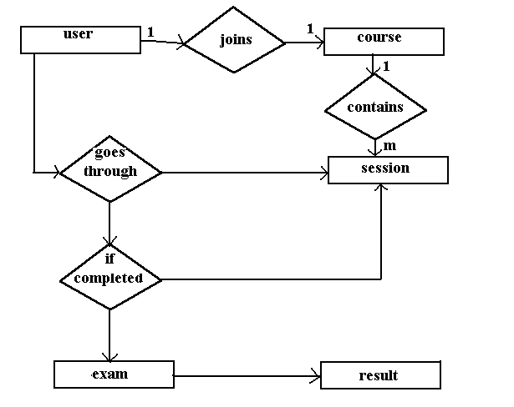

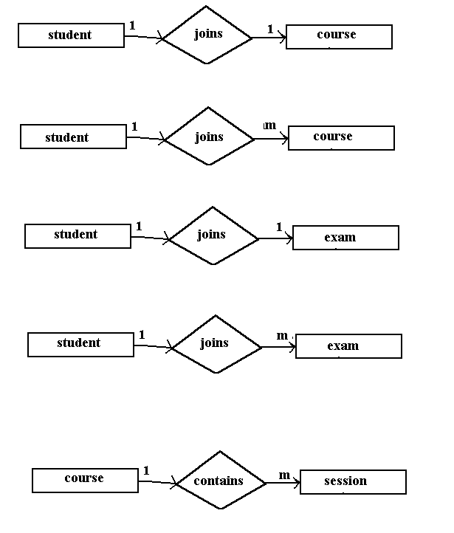

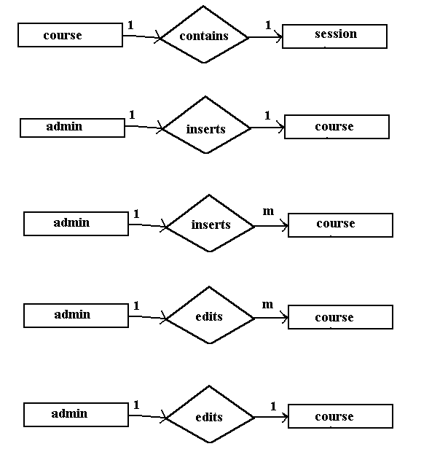

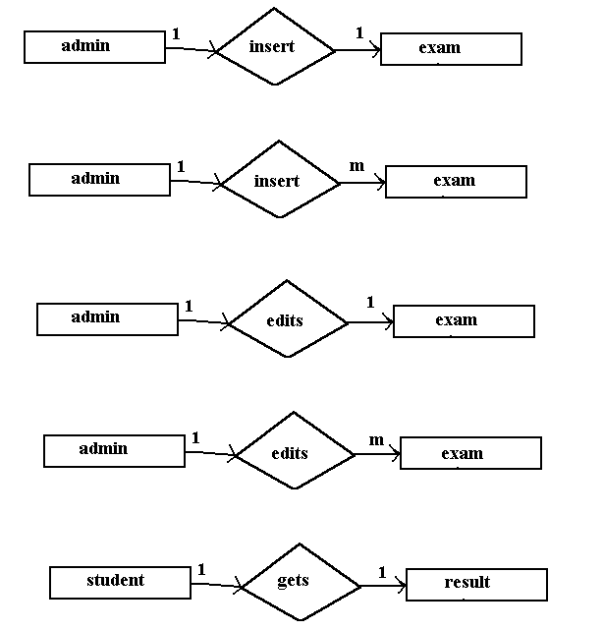

UML

Class Diagram

USERID
COURSEID
EXAMINATION

Registration()

CourseSelection()

Writingexamination()

User :

Object Diagram

User :

UseCase

KnowledgeStorm

Sequence Diagram

:Knowleadgestorm
:Checking
:Course selection
:writing exam
:Details

:Result

Registering

W
O
R
K
I
N
G

Feedback

End

StateChartDiagram

Enter into the site (new user)

Enter your details
Registration
Checking for authorisation
Writing examination
Course selection
Result

Enter id and password

Existing
user

Activity Diagram

Existing user
Enter into the site

New user
Enter your details
Enter id&password
Registration

Check constraints
Course selection
Write examination

Result
Exit from site

Not ok

ok

Use case diagrams

USE CASE DIAGRAM

Course-Registration

Course-Modify
User

administrator

Course-description

Student Reg

Course Study

On Line Examination
Results

Class diagram

Registration

ID
PassWord
Name
Address
State
Email
Country

StoreData()

Login

Name
Password

StoreData()

Examination

Eid
ExamName
Desc
Marks

StoreData()

Course

CourseId
CouresName
Desc

StoreData()

Result

Id
Marks
ExamName
ExamNo

UML Diagrams

UML (UNIFIED MODELLING LANGUAGE)

The unified modeling language is a standard language for specifying, Visualizing, Constructing and Documenting the software system and its components. It is a graphical language which provides a vocabulary and set of semantics and rules. The UML focuses on the conceptual and physical representation of the system. It captures the decisions and understandings about systems that must be constructed.
It is used to understand ,design , configure, maintain and control information about the systems.

Visualizing :

Through UML we see or visualize an existing system and ultimately we visualize how the system is going to be after implementation. Unless we think we cannot implement.

UML helps to visualize how the components of the system communicate and interact with each other.

Specifying :

Specifying means building models that are precise, unambiguous and completeUML addresses the specification of all the important Analysis Design, Implementation decisions that must be made in developing and deploying a software system.

Constructing :UML’s models can be directly connected to a variety of programming language through mapping a model from UML to a programming language like Java or C++ or VB.
Forward Engineering and Reverse Engineering is possible through UML.

Documenting:

The deliverables of a project apart from coding are some artifacts which are critical in controlling, measuring and communicating about a system during its development viz.

Requirements, Architecture, Design, Source code, Project plans, Tests, Prototypes, Releases etc.

Diagrams in UML :

Diagrams are graphical presentation of set of elements . Diagrams projects a system, or visualize a system from different angles and perspectives.

The UML has Nine diagrams these diagrams can be classified into the following groups.
Static:

1. Class diagrams.
2. Object diagrams.
3. Component diagrams.
4. Deployment diagrams

Dynamic:

1. Use case diagram.
2. Sequence diagram.
3. Collaboration diagram.
4. State chart diagram.
5. Activity diagram.

Static or structural diagrams :
Class diagram:

This shows a set of classes, interfaces, collaborations and their relationships. There are the most common diagrams in modeling the object oriented systems and are used to give the static view of a system.
- user id
- course id
- examination

E-Learning

+ regisration()
+ course selection()
+ writing exam()

Object diagram:

Shows a set of objects and their relationships and are used to show the data structures, the static snapshots of instances of the elements in a class diagram. Like class diagram, the object diagrams also address the static design view or process view of a system.

User :

Component diagram:

Shows a set of components and their relationships and are used to illustrate the static implememtation view of a system. They are related to class diagrams where in components map to one or more classes, interfaces of collaborations.

Deployment diagram:

Shows a set of nodes and their relationships. They are used to show the static deployment view of the architecture of a system. They are related to the component diagrams where a node encloses one or more components.

Dynamic or behavioral diagrams:

Use Case diagram:

Shows a set of use cases and actors and their relationships. These diagrams illustrate the static use case view of a system and are important in organizing and modeling the behaviors of a system.

KnowledgeStorm

The user who want to learn through online

Sequence diagram & collaboration diagram:

These two diagrams are semantically same i.e. the dynamics of a system can be modeled using one diagram and transform it to the other kind of diagram without loss of information. Both form the, Interaction diagram.Sequence diagram:
Sequence diagram:

Sequence diagram is an interaction diagram which focuses on the time ordering of messages it shows a set of objects and messages exchange between these objects. This diagram illustrates the dynamic view of a system.

:Knowleadgestorm
:Checking
:Course selection
:writing exam
:Details

:Result

Registering

W
O
R
K
I
N
G

Feedback
End

collaboration diagram:

This diagram is an interaction diagram that stresses or emphasizes the structural organization of the objects that send and receive messages. It shows a set of objects, links between objects and messages send and received by those objects. There are used to illustrate the dynamic vies of a system.
State Chart Diagram and Activity Diagrams:

These Diagrams are semantically similar. State chart diagram shows a state machine consisting of states, transitions and activities these illustrates the dynamic view of a system. They focuses on the event ordered Behavior of an object.

Enter into the site (new user)

Enter your details
Registration
Checking for authorisation
Writing examination
Course selection
Result

Enter id and password

Existing
user

Activity Diagrams:

Activity diagram shows the flow from one activity to another within a system. The activities may be sequential or branching objects that
act and are acted upon. These also show the dynamic view of the system.

Existing user
Enter into the site

New user
Enter your details
Enter id&password
Registration

Check constraints
Course selection
Write examination

Result
Exit from site

Not ok

ok

Analysis is the detailed study of the various operations performed by a system and their relationships within and outside of the system. A key question is: What must be done to solve the problem? One aspect of analysis is defining the boundaries of the system and determining whether or not candidate system should consider other related systems. During analysis, data are collected on the available files, decision points, and transactions handled by the present system.

Modules
- Administration
- User Management
- Content Management
- Evaluation

Module Description

This section attempts to describe each module of the project in brief, and the detailed description of each of these modules is spread throughout this book
Administration:

Uploading the content permanently
- Uploading the content temporally
- Removing the content permanently
- Removing the content temporally
Working options
  - Caching Feature
  - Content length for each Category

User Management:

- User Information
- User Session Maintenance
- Updating User Information

Content Management:
These are the pages that are associated with the logic pages, and contain content specific to that page.
- Organizing the topics according to the category
- Organizing the subtopics according to the subcategory

- Providing appropriate links to specified category

Evaluation:

- Preparing the question paper randomly according to the category
- Spot result evaluation
- Specifying level of evaluation

Feasibility Analysis

Feasibility study is an important phase in the software development process. It enables the developer to have an assessment of the product being developed. It refers to the feasibility study of the product in terms of outcomes of the product, operational use and technical support required for implementing it.

Feasibility study should be performed on the basis of various criteria and parameters. The various feasibility studies are:

- Economic Feasibility
- Operational Feasibility
- Technical Feasibility

- Economic Feasibility: It refers to the benefits or outcomes we are deriving from the product as compared to the total cost we are spending for developing the product. If the benefits are more or less the same as the older system, then it is not feasible to develop the product.
This product is economically feasible as it is a need of every mobile developer. And also because it is commercially available to him on the net, which he can download by paying the reasonable price.

- Operational Feasibility: It refers to the feasibility of the product to be operational. Some products may work very well at design and implementation but may fail in the real time environment. It includes the study of additional human resource required and their technical expertise.
This product is operationally feasible as it is designed specifically for the mobile application developers.Even this product is tested by implementing this in some other projects like Mobile Browser,MMS editor and even in Client Provisioning.

- Technical Feasibility: It refers to whether the software that is available in the market fully supports the present application. It studies the pros and cons of using a particular software for the development and its feasibility. It also studies the additional training needed to be given to the people to make the application work.
As this product is tested by implementation in several other projects. It’s
technical feasibility is guaranteed.

Implementation Plan:
The main plan for the system developed is to mimic the existing system as it is in the proposed system.

SOFTWARE REQUIREMENT SPECIFICATION

What is SRS?
Software Requirement Specification (SRS) is the starting point of the software developing activity. As system grew more complex it became evident that the goal of the entire system cannot be easily comprehended. Hence the need for the requirement phase arose. The software project is initiated by the client needs. The SRS is the means of translating the ideas of the minds of clients (the input) into a formal document (the output of the requirement phase.)
The SRS phase consists of two basic activities:
- Problem/Requirement Analysis:
The process is order and more nebulous of the two, deals with understand the problem, the goal and constraints.
- Requirement Specification:
Here, the focus is on specifying what has been found giving analysis such as representation, specification languages and tools, and checking the specifications are addressed during this activity.
The Requirement phase terminates with the production of the validate SRS document. Producing the SRS document is the basic goal of this phase.

Role Of Srs:
The purpose of the Software Requirement Specification is to reduce the communication gap between the clients and the developers. Software Requirement Specification is the medium though which the client and user needs are accurately specified. It forms the basis of software development. A good SRS should satisfy all the parties involved in the system.

PURPOSE :
The purpose of this document is to describe all external requirements for the KnowledgeStorm System. It also describes the interfaces for the system.

SCOPE :
This document is the only one that describes the requirements of the system. It is meant for the use by the developers , and will also by the basis for validating the final delivered system. Any changes made to the requirements in the future will have to go through a formal change approval process. The developer is responsible for asking for clarifications, where necessary, and will not make any alterations without the permission of the client.

ABOUT SOFTWARE

Overview Of Java Technology
Java, whether you love it, or hate it, it's here to stay. Like everyone's favorite language C, Java has had a major impact on the computing scene. When the history of computers is written, its name will be up there with the stars.
If you were to choose just one language to learn today, it should be Java. It's being pushed aggressively by Sun and is growing by leaps and bounds. There are lots of Java programmers out there and more join the party every day.
Java started out as a bit of an accident. A team under Bill Joy was working at Sun on a new programming language for embedded applications. Java was originally expected to work in toasters and fridges, not on modern computers! The initial prognosis for Java was not good and it was only the rise of the Internet which saved Java from oblivion. Since then, neither the Net nor Sun nor Java has looked back and all have grown from strength to strength.
World wide web is an open ended information retrieval system designed to be used in the distributed environment. This system contains web pages that provide both information and controls. We can navigate to a new web page in any direction. This is made possible worth HTML java was meant to be used in distributed environment such as internet. So java could be easily incorporated into the web system and is capable of supporting animation graphics , games and other special effect. The web has become more dynamic and interactive with support of java. We can run a java program on remote machine over internet with the support of web .

JAVA ENVIRONMENT
Java environment includes a large no.of tools which are part of the system known as java development kit (JDK) and hundreds of classes, methods, and interfaces grouped into packages forms part of java standard library(JSL).

Java Architecture
Java architecture provides a portable , robust , high performing environment for development. Java provides portability by compiling the byte codes for the java virtual machine which are then interpreted on each platform by the runtime environment. Java also provides stringent compile and runtime checking and automatic memory management in order to ensure solid code.

Java Virtual Machine
When we compile the code, java compiler creates machine code (byte code) for a hypothetical machine called java virtual machine (jvm). The jvm will execute the byte code and overcomes the issue of portability . the code is written and compile for one machine and interpreted all other machines . this machine is called java virtual machine .

Paradigm Of Java

- Dynamic down loading applets(small application programs);
- Elimination of flatware phenomenon that is providing those features of a product that user needs at a time. The remaining features of a product can remain in the server.
- Changing economic model of the software
- Up-to-date software availability
- Supports network entire computing
- Supports CORBA & DCOM

An Overview of JSP

The Java Server Pages™ Technology
Java Server Pages™ technology is the Java™ technology in the J2EE platform for building applications containing dynamic Web content such as HTML, DHTML, XHTML and XML. The Java Server Pages technology enables the authoring of Web pages that create dynamic content easily but with maximum power and flexibility.

The Java Server Pages technology provides a textual description for the creation of a response from a request. The technology builds on the following concepts:

Template Data
Substantial portions of dynamic content are actually fixed. The JSP technology allow for the natural manipulation of this data.

Addition of Dynamic Data
The JSP technology allows the addition of dynamic data to the template data in a way that is simple yet powerful.

Encapsulation of Functionality
The JSP technology provides two related mechanisms for the encapsulation of functionality: the standard Java Beans component architecture and the tag library mechanism.

Good Tool Support
The JSP technology has features that enable the creation of good authoring tools. The result is a flexible and powerful server-side technology.

Benefits of the Java Server Pages Technology

The Java Server Pages technology offers a number of benefits:

Write Once, Run Anywhere™ properties
The Java Server Pages technology is platform independent, both in its dynamic Web pages, Web servers, and its underlying server components. You can author JSP pages on any platform, run them on any Web server or Web enabled application server, and access them from any Web browser.

High quality tool support

The Write Once, Run Anywhere properties of JSP allows the user to choose best-of-breed tools. Additionally, an explicit goal of the Java Server Pages design is to enable the creation of high quality portable tools.

Separation of Roles

JSP supports the separation of roles: developers write components that interact with server-side objects.

Reuse of components and tag libraries

The Java Server Pages technology emphasizes the use of reusable components such as Java Beans™ components, Enterprise Java Beans™ components and tag libraries.

Separation of dynamic and static content

The Java Server Pages technology enables the separation of static content from dynamic content that is inserted into the static template.

Support for scripting and actions

The Java Server Pages technology supports scripting elements as well as actions. Actions permit the encapsulation of useful functionality in a convenient form that can also be manipulated by tools; scripts provide a mechanism to glue together this functionality in a per-page manner.

Web access layer for N-tier enterprise application architecture(s)

The Java Server Pages technology is an integral part of the Java 2 Platform Enterprise Edition (J2EE), which brings Java technology to enterprise computing.

About HTML

HTML (hyper text markup language) is a language used to create hyper text documents that have hyper links embedded in them . it consists of tags embedded in the text of a document with HTML. We can build web pages or web document s. it is basically a formatting language and not a programming language. The browser reading the document interprets mark up tags to help format the document for subsequent display to a reader. HTML is a language for describing structured documents. HTML is a platform independent. WWW(world wide web) pages are written using HTML. HTML tags control in part the representation of the WWW page when view with web browser. The browser interpretes HTML tags in the web document and displays it. Different browsers show data differently.

Examples of browsers used to be web pages include:

- Netscape
- Internet Explorer

About JAVA Script

Java script is a general purpose , prototype based , object oriented scripting language developed jointly by Sun and Netscape and is meant for the WWW . it is designed to be embedded in diverse applications and systems , with out consuming much memory . java script borrows most of its syntax from java but also inherits from awk and perl , with some indirect influence from self in its object prototype system.

Java scripts dynamically typed that is programs do not declare variable types, and the type of variable is unrestricted and can change at runtime . source can be generated at run time and evaluated against an arbitrary scope. Typical implementations compile by translating source into a specified byte code format, to check syntax and source consistency. Note that the availability to generate and interprete programs at runtime implies the presence of a compiler at runtime.

Java script is a high level scripting language that does not depend on or expose particular machine representations or operating system services. It provides automatic storage management, typically using a garbage collector.

FEATURES:

- Java script is embedded into HTML documents and is executed with in them.
- Java script is browser dependent
- Javascript is an interpreted languaged that can be interpreted by the browser at run time .
- Java script is loosely typed language
- Java script is an object based language.
- Java script is an Event-Driven language and supports event handlers to specify the functionality of a button.

ADVANTAGES

  - java script can be used for client side application
  - java script provides means to contain multiframe windows for presentation of the web.
  - java script provides basic data validation before it is sent to the server. Eg : login and password checking or whether the values
entered are correct or whether all fields in a from are filled and
reduced network traffic
  - it creates interactive forms and client side lookup tables .

JavaDataBaseConnectivity(JDBC)

Overview of New Features

Result set enhancements
The JDBC 1.0 API provided result sets that had the ability to scroll in a forward direc-tiononally. Scrollable result sets allow for more flexibility in the processing of results by providing both forward and backward movement through their contents. In addition,scrollable result sets allow for relative and absolute positioning. For example, it’s possible to move to the fourth row in a scrollable result set directly, or to move directly to the third row following the current row, provided the row exists. The JDBC API allows result sets to be directly updatable, as well.

Batch updates

The batch update feature allows an application to submit multiple update statements
(insert/update/delete) in a single request to the database. This can provide a dramatic
increase in performance when a large number of update statements need to be executed.

Advanced data types

Increased support for storing persistent Java programming language objects (Java ob-jects) and a mapping for SQL99 data types such as binary large objects, and structured types, has been added to the JDBC API. An application may also customize the mapping of SQL99 structured types into Java programming language classes.

Rowsets

As its name implies, a rowset encapsulates a set of rows. A rowset may or may not maintain an open database connection. When a rowset is ‘disconnected’ from its data source, updates performed on the rowset are propagated to the underlying database using an optimistic concurrency control algorithm.Rowsets add support to the JDBC API for the JavaBeans component model. A rowset object is a bean. A rowset implementation may be serializable. Rowsets can be created at design time and used in conjunction with other JavaBeans components in a visual builder tool to construct an application.

JNDI for naming databases

The Java Naming and Directory Interface (JNDI) API can be used in addition to a JDBC technology-based driver manager (JDBC driver manager) to obtain a connection to a database. When an application uses the JNDI API, it specifies a logical name that identifies a particular database instance and JDBC driver for accessing that database.

This has the advantage of making the application code independent of a particular

JDBC driver and JDBC technology URL.

Connection Pooling

The JDBC API contains ‘hooks’ that allow connection pooling to be implemented on top of the JDBC driver layer. This allows for a single connection cache that spans the different JDBC drivers that may be in use. Since creating and destroying database connectionsis expensive, connection pooling is important for achieving good performance,especially for server applications.

Distributed transaction support

Support for distributed transactions has been added as an extension to the JDBC API.
This feature allows a JDBC driver to support the standard 2-phase commit protocol
used by the Java Transaction Service (JTS) API.

Other new features

Support for character streams has been added. This means that character data can be retrieved and sent to the database as a stream of internationalized Unicode characters.
Methods to allow java.math.BigDecimal values to be returned with full precision have also been added. Support for time zones has been added.

What’s Actually Changed

A New Package

The JDBC API has been factored into two complementary components. The first component is API that is core to the Java platform (the core JDBC 2.1 API ) and comprises the updated contents of the java.sql package. This document contains the specifica-tion for the core JDBC 2.1 API. The second component, termed the JDBC 2.0 Optional Package API, comprises the contents of a new package, javax.sql, which as its name implies will be delivered as an optional package to the Java platform (formerly JavaStandard Extension). The JDBC 2.0 Optional Package API is described in a separate document. The java.sql package contains all of the additions that have been made to the existing interfaces and classes, in addition to a few new classes and interfaces. The new javax.sql package has been introduced to contain the parts of the JDBC API which are closely related to other pieces of the Java platform that are themselves Optional Pack-ages. such as the Java Naming and Directory Interface (JNDI), and the Java Transaction Service (JTS).

In addition, some advanced features that are easily separable from the core JDBC API, such as connection pooling and rowsets, have also been added to javax.sql. Putting these advanced facilities into an optional package instead of into core will help keep the core JDBC API small and focused. Since optional packages are downloadable, it will always be possible to deploy an application which uses the features in the JDBC Optional Package that will “run any-where,” since if an optional package isn’t installed on a client machine, it can be downloaded along with the application that uses it.

Changes to Classes and Interfaces

The list below contains all of the JDBC 2.1 API core classes and interfaces. Interfaces and classes that are new are listed in bold type. All of the interfaces and classes present in the JDBC 1.0 API are also present in the core JDBC 2.1 API, however, some of the JDBC 1.0 technology interfaces have gained additional methods.

The separate core JDBC 2.1 API documentation contains the Java programming language definitions of the java.sql interfaces and classes listed above. The figure below shows the more important core interfaces and their relationships. The important relationships between interfaces have not changed with the introduction of the new JDBCAPI.
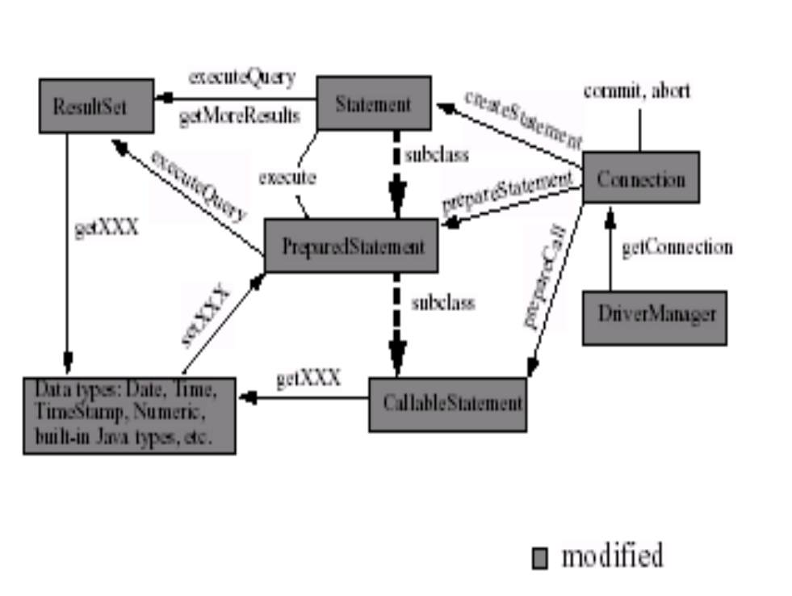

Result Set Enhancements

This chapter discusses the new functionality that has been added to result sets. The goal of the enhancements is to add two new basic capabilities to result sets: scrolling and updatability.Several methods have also been added to enable a JDBC driver to deliver improved performance when processing results. A variety of examples are included to illustrate the new features.

Scrolling

A result set created by executing a statement may support the ability to move backward (last-to-first) through its contents, as well as forward (first-to-last). Result sets that support this capability are called scrollable result sets. Result sets that are scrollable also support relative and absolute positioning. Absolute positioning is the ability to move directly to a row by specifying its absolute position in the result set, while relative positioning gives the ability to move to a row by specifying a position that is relative to the current row. The definition of absolute and relative positioning in the JDBC API is modeled on the X/Open SQL CLI specification.

Result Set types

The JDBC 1.0 API provided one result set type—forward-only. The JDBC 2.1 core API provides three result set types: forward-only, scroll-insensitive, and scroll-sensitive. As their names suggest, the new result set types support scrolling, but they differ in their ability to make changes visible while they are open.

A scroll-insensitive result set is generally not sensitive to changes that are made while
it is open. A scroll-insensitive result set provides a static view of the underlying data it
contains. The membership, order, and column values of rows in a scroll-insensitive resultset are typically fixed when the result set is created. On the other hand, a scroll-
sensitive result set is sensitive to changes that are made while it is open, and provides a ‘dynamic’ view of the underlying data. For example, when using a scroll-sensitive result set, changes in the underlying column values of rows are visible. The membership and ordering of rows in the result set may be fixed—this is implementation defined.

Performance

Two performance hints may be given to a JDBC 2.1 technology-enabled driver to make access to result set data more efficient. Specifically, the number of rows to be fetched from the database each time more rows are needed can be specified, and a direction for processing the rows—forward, reverse, or unknown—can be given as well. These values can be changed for an individual result set at any time. A JDBC driver may ignore a performance hint if it chooses.

Introduction to Servlets
Servlets provide a Java^{(TM)}-based solution used to address the problems currently associated with doing server-side programming, including inextensible scripting solutions, platform-specific APIs, and incomplete interfaces.
Servlets are objects that conform to a specific interface that can be plugged into a Java-based server. Servlets are to the server-side what applets are to the client-side -- object bytecodes that can be dynamically loaded off the net. They differ from applets in that they are faceless objects (without graphics or a GUI component). They serve as platform-independent, dynamically-loadable, pluggable helper bytecode objects on the server side that can be used to dynamically extend server-side functionality.
What is a Servlet?
Servlets are modules that extend request/response-oriented servers, such as Java-enabled web servers. For example, a servlet might be responsible for taking data in an HTML order-entry form and applying the business logic used to update a company's orderdatabase.
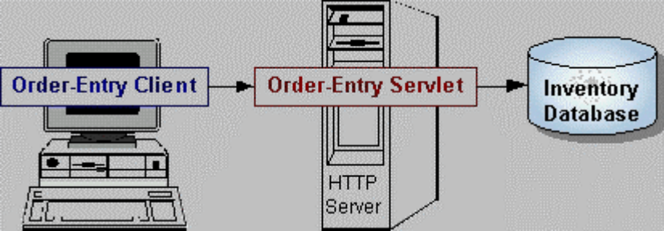

Servlets are to servers what applets are to browsers. Unlike applets, however, servlets have no graphical user interface.
Servlets can be embedded in many different servers because the servlet API, which you use to write servlets, assumes nothing about the server's environment or protocol. Servlets have become most widely used within HTTP servers; many web servers support the Servlet API.

Use Servles instead of CGI Scripts!
Servlets are an effective replacement for CGI scripts. They provide a way to generate dynamic documents that is both easier to write and faster to run. Servlets also address the problem of doing server-side programming with platform-specific APIs: they are developed with the Java Servlet API, a standard Java extension.
So use servlets to handle HTTP client requests. For example, have servlets process data POSTed over HTTPS using an HTML form, including purchase order or credit card data. A servlet like this could be part of an order-entry and processing system, working with product and inventory databases, and perhaps an on-line payment system.
Other Uses for Servlets:
Here are a few more of the many applications for servlets:
- Allowing collaboration between people. A servlet can handle multiple requests concurrently, and can synchronize requests. This allows servlets to support systems such as on-line conferencing.
- Forwarding requests. Servlets can forward requests to other servers and servlets. Thus servlets can be used to balance load among several servers that mirror the same content, and to partition a single logical service over several servers, according to task type or organizational boundaries.

Architecture of the Servlet Package
The javax.servlet package provides interfaces and classes for writing servlets. The architecture of the package is described below.
The Servlet Interface
The central abstraction in the Servlet API is the Servlet interface. All servlets implement this interface, either directly or, more commonly, by extending a class that implements it such as HttpServlet.
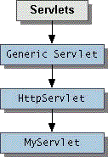
The Servlet interface declares, but does not implement, methods that manage the servlet and its communications with clients. Servlet writers provide some or all of these methods when developing a servlet.
Client Interaction
When a servlet accepts a call from a client, it receives two objects:
- A ServletRequest, which encapsulates the communication from the client to the server.
- A ServletResponse, which encapsulates the communication from the servlet back to the client.

ServletRequest and ServletResponse are interfaces defined by the javax.servlet package.
The ServletRequest interface allows the servlet access to:
- Information such as the names of the parameters passed in by the client, the protocol(scheme) being used by the client, and the name of the remote host that made the request and the server that received it.
- The input stream, ServletInputStream. Servlets use the input stream to get data from clients that use application protocols such as the HTTP POST and PUT methods.
Interfaces that extend ServletRequest interface allow the servlet to retrieve more protocol-specific data. For example, the HttpServletRequest interface contains methods for accessing HTTP-specific header information.
The ServletResponse interface gives the servlet methods for replying to the client. It:
- Allows the servlet to set the content length and MIME type of the reply.
- Provides an output stream, ServletOutputStream, and a Writer through which the servlet can send the reply data.
Interfaces that extend the ServletResponse interface give the servlet more protocol-specific capabilities. For example, the HttpServletResponse interface contains methods that allow the servlet to manipulate HTTP-specific header information.

}
}
That's it!
The classes mentioned in the Architecture of the Servlet Package section are shown in the example in bold:
- SimpleServlet extends the HttpServlet class, which implements the Servlet interface.
- SimpleServlet overrides the doGet method in the HttpServlet class. The doGet method is called when a client makes a GET request (the default HTTP request method), and results in the simple HTML page being returned to the .

Servlet Lifecycle
Each servlet has the same life cycle:
- A server loads and initializes the servlet
- The servlet handles zero or more client requests
- The server removes the servlet

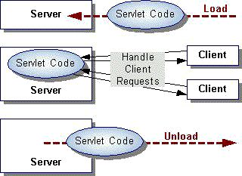

Initializing a Servlet:
When a server loads a servlet, the server runs the servlet's init method. Initialization completes before client requests are handled and before the servlet is destroyed.
Even though most servlets are run in multi-threaded servers, servlets have no concurrency issues during servlet initialization. The server calls the init method once, when the server loads the servlet, and will not call the init method again unless the server is reloading the servlet. The server can not reload a servlet until after the server has destroyed the servlet by calling the destroy method.
The init Method
The init method provided by the HttpServlet class initializes the servlet and logs the initialization. To do initialization specific to your servlet, override the init() method following these rules:
If an initialization error occurs that renders the servlet incapable of handling client requests, throw an UnavailableException.
An example of this type of error is the inability to establish a required network connection.
- Do not call the System.exit method

Initialization Parameters
The second version of the init method calls the getInitParameter method. This method takes the parameter name as an argument and returns a String representation of the parameter's value.
If, for some reason, you need to get the parameter names, use the getParameterNames method.

Destroying a Servlet
Servlets run until the server are destroys them, for example at the request of a system administrator. When a server destroys a servlet, the server runs the servlet's destroy method. The method is run once; the server will not run that servlet again until after the server reloads and reinitializes the servlet. When the destroy method runs, another thread might be running a service request.

Sample Code:

<%@include file="http://localhost:7001/elearn/connect.jsp"%>
<%String method=request.getMethod();
if(method.equals("GET"))
{
%>
<html><body><center><font color=blue><h2>Add a New Course </h2></center><form method=POST action=http://localhost:7001/elearn/AddCourse.jsp><table align='center'><tr><td>Enter Course Name </td><td><input type=text name='course_name'></td></tr><tr><td>Category</td><td><input type=text name='category'></td></tr><tr><td>Number of Sessions</td><td><input type=text name=sessions></td></tr><tr><td><input type=submit value=Store></td><td><input type=reset value=Clear></td></tr></table></form></body></html>
<%
}
else if(method.equals("POST"))
{
String coursename = request.getParameter("course_name");
String sessions = request.getParameter("sessions");
String category = request.getParameter("category");
try
{
Statement st=con.createStatement();
ResultSet rs=st.executeQuery("select nvl(max(substr(course_id,2)),0) + 1 from courses ");
rs.next();
String cd=rs.getString(1);
String cid = "c" +cd;
PreparedStatement ps = con.prepareStatement("insert into courses values(?,?,?,?) ");
ps.setString( 1, cid);
ps.setString( 2, coursename);
ps.setString( 3, category);
ps.setString( 4, sessions);
ps.executeUpdate();
ps.close();
rs.close();
st.close();
%>
<html><body bgcolor=#FFFFFF><center><font color=blue><h2>Course Added Succesfully</h2><br>
<font color=red>The Course Id Generated was :</font><%=cid%>

<br><br><b>Make Sure You Provide Session Beak Up's and Data so that students can make use of Your valuable course</b></font><br><br><a href=http://localhost:7001/elearn/admin.html>Admin Home </a></body></html>
<%
}catch(Exception e){ e.printStackTrace(); }
}
%>

<%@page import="java.io.*"%>
<%@include file="http://localhost:7001/elearn/connect.jsp"%>
<%String method=request.getMethod();
if(method.equals("GET"))
{

%>
<html><body><font color=blue><h2><center>Add Exam For an Existing Course</center> </h2><form method=POST action=http://localhost:7001/elearn/AddExam.jsp><br><br><table align='center'><tr><td><b>Choose Course ID:<select name='CID'>

<%
try{
Statement st = con.createStatement();
ResultSet rs = st.executeQuery("select course_id from courses order by 1");
while( rs.next())
{
String ci=rs.getString(1);
%>
<option><%=ci%><br>
<%
}
rs.close();
st.close();
%>
</select></b></td></tr><tr><td><input type=submit value='--Add--'></td><tr></table></form></font></body></html>
<%
}catch(Exception e){
e.printStackTrace();

}
}
else if(method.equals("POST"))
{
String cid=request.getParameter("CID");
%>
<html><body><font color=blue><h2><center>Examination Paper For the Course Id : <%=cid%></center></h2><br><br><form action=http://localhost:7001/elearn/InsertExam.jsp method=POST><table border=1 align='center'>
<%
try{
%>
<tr><td>Course Id </td><td><input type=text name=cid value=<%=cid%>></td></tr>
<tr><td>Question Id </td><td><input type=text name=qid></td></tr>
<tr><td>Question Description </td><td><input type=text name=qd size=50></td></tr>
<tr><td>Option 1 </td><td><input type=text name=op1></td></tr>
<tr><td>Option 2 </td><td><input type=text name=op2></td></tr>
<tr><td>Option 3 </td><td><input type=text name=op3></td></tr>
<tr><td>Option 4 </td><td><input type=text name=op4></td></tr>
<tr><td>Answer </td><td><input type=text name=ans></td></tr>
<tr><td><input type=submit value='Insert'></td><td><input type=reset value='Clear'></td></tr></form></font></body></html>

<%
con.close();
}
catch(Exception e)
{
e.printStackTrace();
}
}

<%@include file="http://localhost:7001/elearn/connect.jsp"%>
<%String method=request.getMethod();%>
<% if(method.equals("POST"))
{

String uname=request.getParameter("username");
String pwd=request.getParameter("password");
try{
Statement st=con.createStatement();
ResultSet rs=st.executeQuery("select * from admin where uname =" +"'"+uname+"'"+" and pwd = "+"'"+pwd+"'");
if(rs.next())
{
%>
<html><body bgcolor=#FFFFFF><center><h2> Welcome To Admin Page <font color=blue > <%=uname %></font></h2>
<br><table align='center'><tr><td><a href ='http://localhost:7001/elearn/AddAdmin.jsp'>Add An Adiministrator</a></td></tr>
<tr><td></td></tr><tr><td><a href ='http://localhost:7001/elearn/AddCourse.jsp'>Add New Course</a></td></tr>
<tr><td></td></tr><tr><td><a href ='http://localhost:7001/elearn/DelCourse.jsp'>Delete Course</a></td></tr>
<tr><td></td></tr><tr><td><a href ='http://localhost:7001/elearn/ModifyCourse.jsp'>Modify </td></tr>
<tr><td></td></tr><tr><td><a href ='http://localhost:7001/elearn/AddExam.jsp' >Add New Exam<a></td></tr>
</center></body><html>
<%
}
else{
%>
<html><body bgcolor=#FFFFFF><center><h2><font
color=red><h2> You are not an Authorised Person to View this Page </h2><br>
<input type=button value='Go Back' onClick=history.back()>
</center></body><html>
<% }

rs.close();
st.close();
con.close();
}catch(Exception e){ e.printStackTrace(); }
}
%>

<%@page language="java" import="java.sql.*,java.util.*,javax.sql.*,javax.naming.*" Content-Type="text/html"%>
<%
Connection con;

Properties p = new Properties();

p.put(Context.INITIAL_CONTEXT_FACTORY,"weblogic.jndi.WLInitialContextFactory");

InitialContext ctx = new InitialContext(p);

DataSource ds = (DataSource)ctx.lookup("epool");

con = ds.getConnection();
%>

<%@page import="java.net.*,java.io.*"%>
<%@include file="http://localhost:7001/elearn/connect.jsp"%>
<%String method=request.getMethod();
if(method.equals("GET"))
{
String sid=request.getParameter("cc");
String cid=request.getParameter("cid");
try{
%>
<html><body><center><font color=blue><h3>Session Information</h3></font></center>
<form action='http://localhost:7001/elearn/CourseContent.jsp' method=POST><hr>
<input type=hidden name=cid value=<%=cid%>><input type=hidden name=sid value=<%=sid%>>
<font color=red><b>Paste The Content Below In Html Format :</b></font><textarea name=ta cols=70 rows=20></textarea><br><input type=submit value=Paste>&nbsp;&nbsp;&nbsp;<input type=reset value=Clear>
<%
}catch(Exception e){
%> <pre>
<%
e.printStackTrace(out);
%>
</pre>

}
out.close();
}
else if(method.equals("POST"))
{
try{
String cid=request.getParameter("cid");
String sid=request.getParameter("sid");
String fc=request.getParameter("ta");
String fname="c:\\"+cid+sid+".html";
FileOutputStream fout=new FileOutputStream(fname);
fout.write(fc.getBytes(),0,fc.length());
fout.flush();
PreparedStatement ps=con.prepareStatement("insert into session_details values(?,?,?)");
ps.setString(1,cid);
ps.setString(2,sid);
ps.setString(3,fname);
int i=ps.executeUpdate();
%>
<html><body><center><font color=blue><h3>Updated Successfully</h3></font><br><input type=button value=Close onCLick='window.close()'></center></body></html>
<%
con.close();
}catch(Exception e){
e.printStackTrace();
}
}
%>

<%@page import="java.io.*,java.net.*"%>
<%@include file="http://localhost:7001/elearn/connect.jsp"%>
<%String method=request.getMethod();
if(method.equals("GET"))
{
String id=request.getParameter("id");
try
{
Statement st = con.createStatement();
String sql = "select * from courses where course_name='"+id.trim()+"'";
ResultSet rs = st.executeQuery(sql);
ResultSetMetaData rsmd = rs.getMetaData();

int cols = rsmd.getColumnCount();
%>

<center> <font size=5 face='Geneva, Arial, Helvetica, ans-serif'><cite>Courses Information </cite></font></center>
<table width=75% border=1 align=center bordercolor='#0000FF'>
<tr> <font color=red>
<%
for(int i=1;i<=cols;i++)
{
String name=rsmd.getColumnLabel(i);
%>
<th> <%=name%></th>

<%
}
rs.next();
%>
</font> </tr>
<tr>
<%
String cid = "";
String s;

for(int i=1;i<=cols;i++)
{
if(i==1)
{
cid = rs.getString(1);
s = cid;
}
else
s = rs.getString(i);
if(s==null || s.equals(""))
{
%>
<td> </td>
<%
}
else
{
%>
<td><%=s%></td>
<%
}

}
%>
</tr></table>
<hr><center>Details<hr>
<%
rs.close();
st.close();
st = con.createStatement( );
rs = st.executeQuery("select * from course_details where course_id ='" +cid+ "' order by session_no " );
%>
<table border=1 width=50%>
<tr><th>Session No</th><th>Topic</th></tr>
<%
while( rs.next())
{
cid=rs.getString(1);
String sessid=rs.getString(2);
String topic=rs.getString(3);
%>
<tr><td><%=sessid%></td><td><a href=http://localhost:7001/elearn/TopicRead.jsp?id=<%=cid%>&sid=<%=sessid%>><%=topic%></a></td></tr>
<%
}
%>
</table></center>
<%
rs.close();
st.close();
con.close();
}catch(Exception e){
%>
<pre>
<%
e.printStackTrace(out);
%>
</pre>
<%
}
out.close();
}

<%@include file="http://localhost:7001/elearn/connect.jsp"%>
<%@page import="java.io.*,java.net.*" session="true"%>
<%String method=request.getMethod();
if(method.equals("GET"))
{

String uname=(String)session.getValue("uname");
String pass=(String)session.getValue("pass");
if((uname == null) || (pass == null))
{
%>
<html><body><center><font color=blue><br><h3>First Login using your Userid and Password then Access Course Infomation </h3></font><br><a href='http://localhost:7001/elearn/login.html'>Sign In </a></center></body></html>

<%
return;
}
try{
Statement st = con.createStatement();
ResultSet rs = st.executeQuery("select course_cat,course_name from courses");
%>

<center> <font size=5 face='Geneva, Arial, Helvetica, ans-serif'><cite>Courses Information </cite></font></center>
<table width=75% border=1 align=center bordercolor='#0000FF'>
<tr> <font color=red>
<th> Course Category </th>
<th> Course Name</th>
</font> </tr>

<%
while(rs.next()){
%>
<tr>
<%
for(int i=1;i<=2;i++){
String s = rs.getString(i);
if(s==null || s.equals(""))
{
%>
<td> </td>
<%

}
else{
%>
<td>

<%
if(i==2)
{
%>
<a href=http://localhost:7001/elearn/CourseDetails.jsp?id=<%=URLEncoder.encode(s)%>><%=s%></td>

<%
}
else
{
%>
<%=s%></td>
<%
}
}

}
%>
</tr>
<%
}
rs.close();
st.close();
con.close();
%>
</table>

<%
}catch(Exception e){
%>
<pre>
<%
e.printStackTrace(out);
%>
</pre>
<%
}
out.close();

}
%>

<%@page import="java.io.*"%>
<%@include file="http://localhost:7001/elearn/connect.jsp"%>
<%String method=request.getMethod();
if(method.equals("GET"))
{
%>
<html><body><font color=blue><h2><center>Delete an Existing Course</center> </h2><form method=POST action=http://localhost:7001/elearn/DelCourse.jsp><br><br><table align='center'><tr><td><b>Choose Course ID:<select name='CID'> ");
<%
try{
Statement st = con.createStatement();
ResultSet rs = st.executeQuery("select course_id from courses order by 1");
while( rs.next())
{
String ci=rs.getString(1);
%>
<option> <%=ci%><br>
<%
}
rs.close();
st.close();
con.close();
%>
</select></b></td></tr><tr><td><input type=submit value='Delete'></td><tr></table></form></font></body></html>
<%
}catch(Exception e){
e.printStackTrace();
}
}
else if(method.equals("POST"))
{
%>
<html><body><font color=blue><h2><center>Deleting The Course Details</center></h2><br><br>

<%
String cid=request.getParameter("CID");
try{
PreparedStatement ps = con.prepareStatement("delete from courses where course_id =?");
ps.setString(1 ,cid);
ps.execute();
ps.close();
%>
You Have Successfully Remove the Course Details<br> <input type=button value='Go Back' onClick='history.back()'></form>
<%
}catch(Exception e){
e.printStackTrace();
}
}
%>
</font></body></html>

<%@page session="true" import="java.io.*, Q1.Questions" %>
<%@include file="http://localhost:7001/elearn/connect.jsp"%>
<% String method=request.getMethod();
Random r=new Random();
Vector v;
if(method.equals("GET"))
{
String uname=(String)session.getValue("uname");
String pass=(String)session.getValue("pass");
if((uname == null) || (pass == null))
{
%>
<html><body><center><font color=blue><br><h3>First Login using your Userid and Password then Access Course Infomation </h3></font><br><a href='http://localhost:7001/elearn/login.html'>Sign In </a></center></body></html>
<%
return;
}
session.putValue("uname",uname);
%>
<html><body><font color=blue><h2><center>Select Exam For an Existing Course</center> </h2><form method=POST

action=http://localhost:7001/elearn/Examination.jsp><br><br><table align='center'><tr><td><b>Choose Course ID:<select name='CID'>
<%
try
{
Statement st = con.createStatement();
ResultSet rs = st.executeQuery("select course_id from courses order by 1");
while( rs.next())
{
String ci=rs.getString(1);
%>
<option><%=ci%><br>
<%
}
rs.close();
st.close();
%>
</select></b></td></tr><tr><td><input type=submit value='--Select--'></td><tr></table></form></font></body></html>

<%
}catch(Exception e){
e.printStackTrace();
}
}
else if(method.equals("POST"))
{
try
{
String cid=request.getParameter("CID");
System.out.println("cid is :"+cid);
String uname=(String)session.getValue("uname");
session.putValue("uname",uname);
%>
<html><body><font color=blue><h2><center>Examination Paper For the Course Id : <%=cid%></center></h2><br><br><form action=http://localhost:7001/elearn/Result.jsp method=GET>

<%
Statement st=con.createStatement();
ResultSet rs=st.executeQuery("select * from question_answer where course_id='"+cid+"'");
v=new java.util.Vector();
while(rs.next())
{
Questions q=new Questions();
q.cid=rs.getString(1);
q.qid=rs.getString(2);
q.qd=rs.getString(3);
q.op1=rs.getString(4);
q.op2=rs.getString(5);
q.op3=rs.getString(6);
q.op4=rs.getString(7);
q.ans=rs.getString(8);
v.addElement(q);
}
st.close();
rs.close();
con.close();
System.out.println("Vector :"+v);
Integer i=new Integer(0);
System.out.println(System.getProperty("user.dir"));
//int r1=r.nextInt(1000);
long r1=Math.round((Math.random()*1000));
System.out.println(System.getProperty("user.dir"));
ObjectOutputStream obj=new ObjectOutputStream(new FileOutputStream("obj"+r1));
v.addElement(i);
obj.writeObject(v);
obj.close();
response.sendRedirect("http://localhost:7001/elearn/Result.jsp?fn=obj"+r1);
}catch(Exception e){
e.printStackTrace();
}
}
%>

<%@page import="java.io.*"%>
<%@include file="http://localhost:7001/elearn/connect.jsp"%>
<%!PreparedStatement ps;%>
<%String method=request.getMethod();

try
{
ps=con.prepareStatement("insert into question_answer values(?,?,?,?,?,?,?,?)");

}
catch(Exception e){System.out.println(e); }

if(method.equals("POST"))
{
%>

<html><body>

<%
try
{
String cid=request.getParameter("cid");
String qid=request.getParameter("qid");
String qd=request.getParameter("qd");
String op1=request.getParameter("op1");
String op2=request.getParameter("op2");
String op3=request.getParameter("op3");
String op4=request.getParameter("op4");
String ans=request.getParameter("ans");
System.out.println(cid +" "+qid +" "+qd +" "+op1 +" "+op2 +" "+op3 +" "+op4 +" "+ans);
if(cid.equals("") || cid == null || qid.equals("") || qid == null || qd.equals("") || qd == null || op1.equals("") || op1 == null || op2.equals("") || op2 == null || op3.equals("") || op3 == null || op4.equals("") || op4 == null || ans.equals("") || ans == null)
{
%>

<h3><font color=red><center>The Required Details are Insufficient <br><br><br><input type=button value=Back onClick='history.back()'> </center></h3>

<%
}
else
{
ps.setString(1,cid);
ps.setString(2,qid);
ps.setString(3,qd);
ps.setString(4,op1);
ps.setString(5,op2);
ps.setString(6,op3);
ps.setString(7,op4);
ps.setString(8,ans);
ps.execute();
%>

<font color=blue><h3>Exam Details Added Successfully</font><br><br><a href=http://localhost:7001/elearn/admin.html>Admin Home</a></h3>

<%
}
ps.close();
con.close();
}
catch(Exception e)
{
e.printStackTrace();
}
}

<%@page sesson="true"%>
<%@include file="http://localhost:7001/elearn/connect.jsp"%>
<%String method=request.getMethod();
if(method.equals("GET"))
{

session.invalidate();
%>
<html><body><font color=blue><h2><center>Modify an Existing Course</center> </h2><form method=POST action=http://localhost:7001/elearn/ModifyCourse.jsp ><br><br><table align='center'><tr><td><b>Choose Course ID:<select name='CID'>
<%
try{
Statement st = con.createStatement();
ResultSet rs = st.executeQuery("select course_id from courses order by 1");
while( rs.next())
{
String cid=rs.getString(1);
%>
<option><%=cid%> </option><br>
<%
}
rs.close();
st.close();
%>
</select></b></td></tr><tr><td><input type=submit value='--GO--'></td><tr></table></form></font></body></html>
<%
}catch(Exception e){
e.printStackTrace();
}
}

else if(method.equals("POST"))
{

if (session.getValue("CID") == null)
session.putValue("CID" , request.getParameter("CID"));
String cid = (String)session.getValue("CID");
%>
<html><body><font color=blue><h2><center>Modify The Course Id :<%=cid%> Details</center></h2><br><br><form action=http://localhost:7001/elearn/ModifyCourse.jsp method=POST><table border=1 align='center'><tr color='cyan'><th>Delete</th><th>Session Number</th><th>Topic</th></tr>
<%
Statement st = null;
try{
String add=request.getParameter("ADD");
if( add!= null && ! add.equals("")){
PreparedStatement ps = con.prepareStatement("insert into course_details values( ?,?,?) ");
ps.setString(1 ,cid);
ps.setString(2 ,request.getParameter("session_NO"));
ps.setString(3 ,request.getParameter("topic") );
ps.executeUpdate();
ps.close();
}

if( request.getParameter("DEL") != null && ! request.getParameter("DEL").equals("")){
String[] values = request.getParameterValues( "C");
PreparedStatement ps =con.prepareStatement("delete from course_details where course_id=? and session_no=?");
for(int i=0;i<values.length;i++){
System.out.println("deleting " + values[i]);
ps.setString( 1 , cid);
ps.setString(2 , values[i]);
ps.executeUpdate();
}
ps.close();
}

st =con.createStatement();

ResultSet rs = st.executeQuery("select * from course_details where course_id='" + cid + "' order by session_no" );
while( rs.next()){
cid=rs.getString(1);
String sess=rs.getString(2);
String topic=rs.getString(3);
%>
<tr><td><input type=checkbox name=C value=<%=sess%>></td><td><%=sess%></td><td><a href='#' onClick=window.open('http://localhost:7001/elearn/CourseContent.jsp?cid=<%=cid%>&cc=<%=sess%>','CourseContent','toolbar=0,scrollbars=1,width=500,height=500'); return false;><%=topic%></a></td></tr>
<%
}

rs.close();
st.close();
%>
<tr><td><input type=submit value=Add name=ADD></td><td><input type=text name=session_NO></td><td><input type=text name=topic></td></tr><tr><td cellspan=3>
<input type=submit value='Delete All' name='DEL'></td></tr></table></form></font></body></html>
<%
con.close();
}catch(Exception e){
e.printStackTrace();
}
}

<%@page import="java.io.*" session="true"%>
<%@include file="http://localhost:7001/elearn/connect.jsp"%>
<%String method=request.getMethod();
if(method.equals("GET"))
{
try
{
String uname=request.getParameter("username");
String pass=request.getParameter("password");

Statement st=con.createStatement();
ResultSet rs=st.executeQuery("select * from ereg where userid ="+"'"+uname+"'"+"and password = "+"'"+pass+"'");
if(!rs.next())
{
%>

<html><body><center><font color=blue><br><h3>Not a Valid UserName Or Password Try with Valid User Name & Password </h3><input type=button value=Back onClick='history.back()'></center>
<%
}
else
{
session.putValue("uname",uname);
session.putValue("pass",pass);
%>

<html><body><center><font color=blue><br><h3>Welcome to Elearning Site <%=rs.getString(3)%></h3><hr>
<br><table align='center'><tr><td><a href ='http://localhost:7001/elearn/Courses.jsp'>Availale Courses </a></td></tr>
<tr><td></td></tr><tr><td><a href ='http://localhost:7001/elearn/Examination.jsp'>Examination</a></td></tr></table>
</center></body><html>

<%
}
con.close();
}
catch(Exception e){ e.printStackTrace();
}
}

IMPLEMENTATION & USER MANUAL

IMPLEMENTATION:

In this implementation phase we are mentioning some sample code.Here I am putting the code for the program of LOGIN form.First we putting HTMLfile. Here we don’t check really for authorized users.Here we are just linking with jsp file and do some design process.

<!DOCTYPE HTML PUBLIC "-//W3C//DTD HTML 4.0 Transitional//EN">
<HTML><HEAD><TITLE> Member Login</TITLE>
<META http-equiv=content-type content=text/html;charset=iso-8859-1>
<SCRIPT language=JavaScript type=text/javascript>
<!--
function reg(){
if (window.opener == null) {
window.document.location.href = 'http://localhost:7001/elearn/register.html';
} else {
window.opener.location.href = 'http://localhost:7001/elearn/register.html';
self.close();
}
}
//-->
</SCRIPT>
<table>
<tr><td><a href="http://localhost:7001/elearn/home.html">Home</a></td><td></td><td></td><td></td><td></td><td></td>

<td><a href="http://localhost:7001/elearn/login.html">Login</a></td><td></td><td></td><td></td><td></td><td></td>
<td>
<a href="http://localhost:7001/elearn/register.html">Register</a></td><td></td><td></td><td></td><td></td><td></td>
<td></td><td></td><td></td>
<a href="http://localhost:7001/elearn/Courses.jsp"></a></td><td></td><td></td><td></td><td></td><td></td>
<td><a href="http://localhost:7001/elearn/Examination.jsp">Examination</a></td><td></td><td></td><td></td><td></td><td></td>
<td><a href="http://localhost:7001/elearn/admin.html">Administration</a></td><td></td><td></td><td></td><td></td><td></td>
<td><a href="http://localhost:7001/elearn/index.htm">Help</a></td></tr>
</table>

<!-- body and font included in header.inc -->
<META content="MSHTML 6.00.2600.0" name=GENERATOR></HEAD>
<BODY bgColor=white leftMargin=5 topMargin=5 marginheight="5" marginwidth="5">
<blockquote>
<blockquote>
<blockquote>
<blockquote>
<p><BR>
</p>

<p>&nbsp;</p>
<p><FONT face=arial size=2><B>Members: Sign Up Now - it's FREE!</B><BR>
<BR>
Every User is eligible to register &amp; take advantage of the<BR>
many resources offered on <A
href="http://www.elearn.com/">Elearning Portal</A></FONT> <BR>
<BR>
<FONT
face=arial size=2><B>First-time User? <A href="javascript:reg();">Register here</A></B>.</FONT>
<FONT face=Arial,Helvetica,Geneva,Swiss,SunSans-Regular
size=2><BR>
</FONT> </p>
</blockquote>
</blockquote>
</blockquote>
</blockquote>
<FORM name=xyz action="http://localhost:7001/elearn/UserValid.jsp" method=get>
<FONT
face=Arial,Helvetica,Geneva,Swiss,SunSans-Regular color=#336699 size=2>
<TABLE cellSpacing=0 cellPadding=4 width=137 border=0 align="center">
<TBODY>
<TR>
<TD><FONT face=Arial,Helvetica,Geneva,Swiss,SunSans-Regular color=#336699
size=2>USERNAME:</FONT></TD>
<TD><INPUT size=15 name=username></TD>
</TR>
<TR>

<TD><FONT face=Arial,Helvetica,Geneva,Swiss,SunSans-Regular color=#336699
size=2>PASSWORD:</FONT></TD>

<TD><INPUT type=password size=15 name=password></TD>
</TR>
<TR>
<TD></TD>
<!-- <td align="right"><a href="javascript:openWin()"><img height="18" width="52" src="http://localhost:7001/elearn/but-login.gif" border="0" vspace="5"></a></td> -->
<TD align=right><INPUT type=image height=18 width=52
src="http://localhost:7001/elearn/but-login.gif" name=submit> </TD>
</TR>
</TBODY>
</TABLE></center>
<blockquote>
<blockquote>
<blockquote>
<blockquote>
<p>
<INPUT type=hidden
value=/members+only/legislative/gr_acct_menu.htm name=url>
<INPUT type=hidden
value=/members+only/legislative/gr_acct_menu.htm name=ReqURL>
</p>
</blockquote>
</blockquote>

</blockquote>
</blockquote>
</FORM>
<TABLE>
<TBODY>

<TR>
<TD width=200> <CENTER>
<!--<a target=_blank href="/cab/cab_tpsprogram.htm">
<img src="/aba/images/cabtpsad.gif" border=0></a>-->
</CENTER></TD>
</TR>
</TBODY>
</TABLE>
<!--<font face="arial" size="2">Have a question? Visit our<a href="#" onClick="window.open('http://www.aba.com/about+aba/faq.htm','FAQ');">FAQ's</a>. </font>-->
<!--<table><tr><td><font size="3" color="red" face="Arial,Helvetica,Geneva,Swiss,SunSans-Regular"><b>TROUBLE LOGGING IN?</b></font><hr>
<font size="2" color="red" face="Arial,Helvetica,Geneva,Swiss,SunSans-Regular"><b>Please <a href="http://www.aba.com">click here</a> to return to the <a href="http://www.aba.com">www.aba.com</a> homepage and then REFRESH YOUR BROWSER </font><font size="2" face="Arial,Helvetica,Geneva,Swiss,SunSans-Regular">- or try back later as access is intermittent.</b> Thanks for your patience while we resolve this issue.</font></td></tr></table>-->
</BODY></HTML>

Now I am putting the JSP file of the above login form. In this file we are checking for authorized users to access the details of the firm and if the user is new then it shows the registration form.

.
<%@include file="connect.jsp"%>
<%String method=request.getMethod();%>

<% if(method.equals("POST"))
{
String uname=request.getParameter("username");
String pwd=request.getParameter("password");
try{
Statement st=con.createStatement();
ResultSet rs=st.executeQuery("select * from admin where uname =" +"'"+uname+"'"+" and pwd = "+"'"+pwd+"'");
if(rs.next())
{
%>
<html><body bgcolor=#FFFFFF><center><h2> Welcome To Admin Page <font color=blue > <%=uname %></font></h2>
<br><table align='center'><tr><td><a href ='http://localhost:7001/elearn/AddAdmin.jsp'>Add An Adiministrator</a></td></tr>
<tr><td></td></tr><tr><td><a href ='http://localhost:7001/elearn/AddCourse.jsp'>Add New Course</a></td></tr>
<tr><td></td></tr><tr><td><a href ='http://localhost:7001/elearn/DelCourse.jsp'>Delete Course</a></td></tr>
<tr><td></td></tr><tr><td><a href ='http://localhost:7001/elearn/ModifyCourse.jsp'>Modify </td></tr>
<tr><td></td></tr><tr><td><a href ='http://localhost:7001/elearn/AddExam.jsp' >Add New Exam<a></td></tr>

</center></body><html>
<%
}
else{
%>
<html><body bgcolor=#FFFFFF><center><h2><font
color=red><h2> You are not an Authorised Person to View this Page </h2><br>

<input type=button value='Go Back' onClick=history.back()>
</center></body><html>
<% }

rs.close();
st.close();
con.close();
}catch(Exception e){ e.printStackTrace(); } }
%>

TESTING

Testing is a process, which reveals errors in the program. It is the major quality measure employed during software development. During software development. During testing, the program is executed with a set of test cases and the output of the program for the test cases is evaluated to determine if the program is performing as it is expected to perform.

In order to make sure that the system does not have errors, the different levels of testing strategies that are applied at differing phases of software development are:

1. Unit Testing:

Unit Testing is done on individual modules as they are completed and become executable. It is confined only to the designer's requirements.

Each module can be tested using the following two
Strategies:

- Black Box Testing:

In this strategy some test cases are generated as input conditions that fully execute all functional requirements for the program.This testing has been uses to find errors in the following categories:
a) Incorrect or missing functions
b) Interface errors
c) Errors in data structure or external database access
d) Performance errors
e) Initialization and termination errors.

In this testing only the output is checked for correctness.

The logical flow of the data is not checked.

- White Box testing :
In this the test cases are generated on the logic of each module by drawing flow graphs of that module and logical decisions are tested on all the cases.It has been uses to generate the test cases in the following cases:

  - Guarantee that all independent paths have been Executed.
  - Execute all logical decisions on their true and false Sides.
c) Execute all loops at their boundaries and within their
operational bounds.
d) Execute internal data structures to ensure their validity.

2. Integrating Testing :

Integration testing ensures that software and subsystems work togethers a whole. It tests the interface of all the modules to make sure that the modules behave properly when integrated together.

3. System Testing :

Involves in-house testing of the entire system before delivery to the user. It's aim is to satisfy the user the system meets all requirements of the client's specifications.

4. Acceptance Testing :

It is a pre-delivery testing in which entire system is tested at client's site on real world data to find errors.

Test Approach :

Testing can be done in two ways:

Bottom up approach
Top down approach

Bottom up Approach:

Testing can be performed starting from smallest and lowest level modules and proceeding one at a time. For each module in bottom up testing a short program executes the module and provides the needed data so that the module is asked to perform the way it will when embedded with in the larger system. When bottom level modules are tested attention turns to those on the next level that use the lower level ones they are tested individually and then linked with the previously examined lower level modules.

Top down approach:

This type of testing starts from upper level modules. Since the detailed activities usually performed in the lower level routines are not provided stubs are written. A stub is a module shell called by upper level module and that when reached properly will return a message to the calling module indicating that proper interaction occurred. No attempt is made to verify the correctness of the lower level module.

Validation:

The system has been tested and implemented successfully and thus ensured that all the requirements as listed in the software requirements specification are completely fulfilled. In case of erroneous input corresponding error messages are displayed.

SCREENS AND FORMS

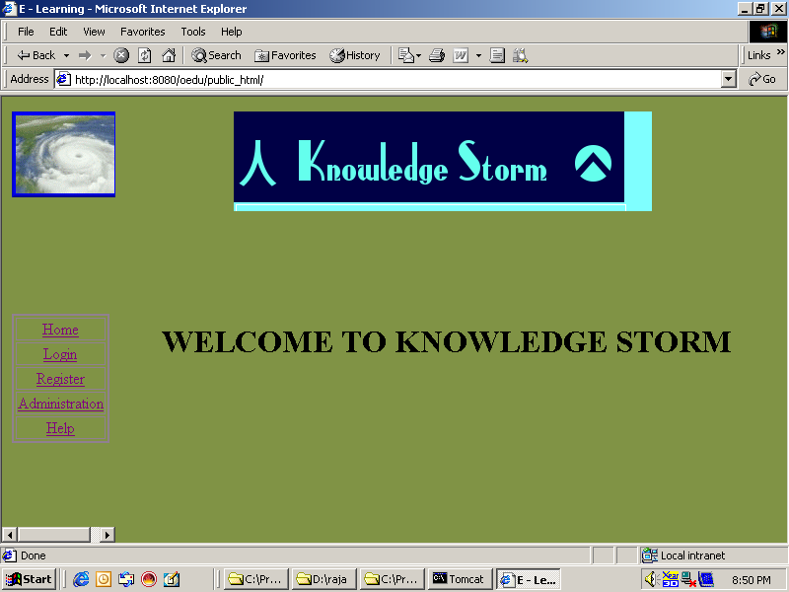

Welcome page of knowledge storm.

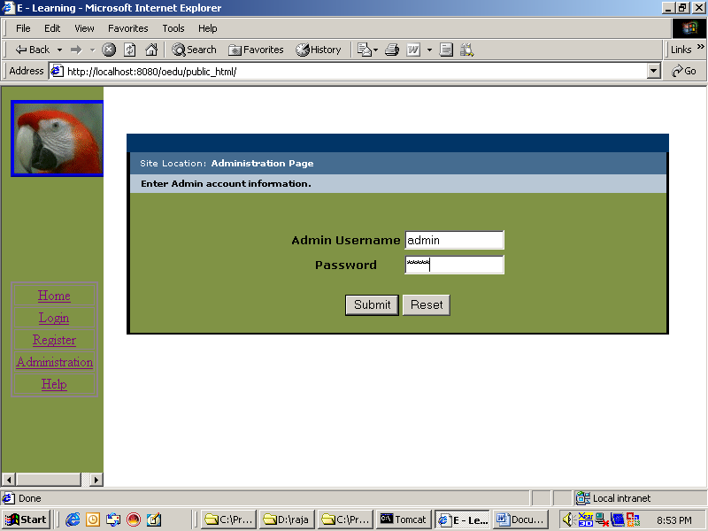

Admin login page
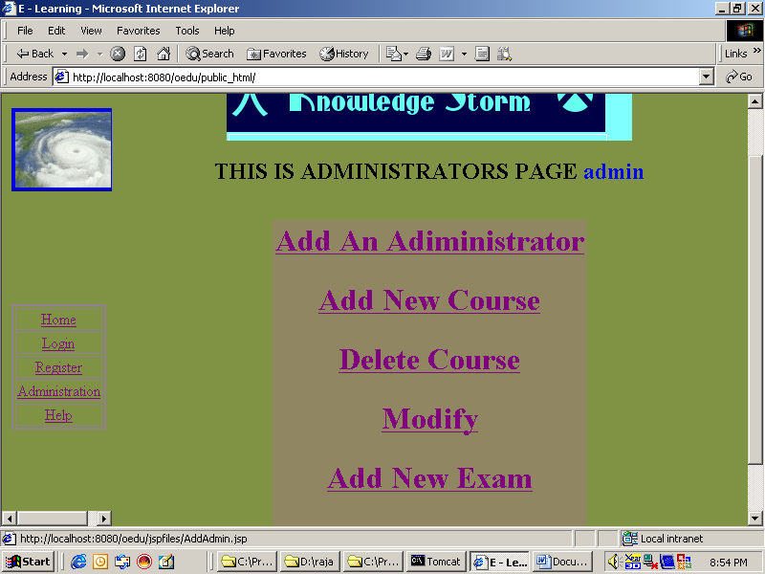

Administrators details page
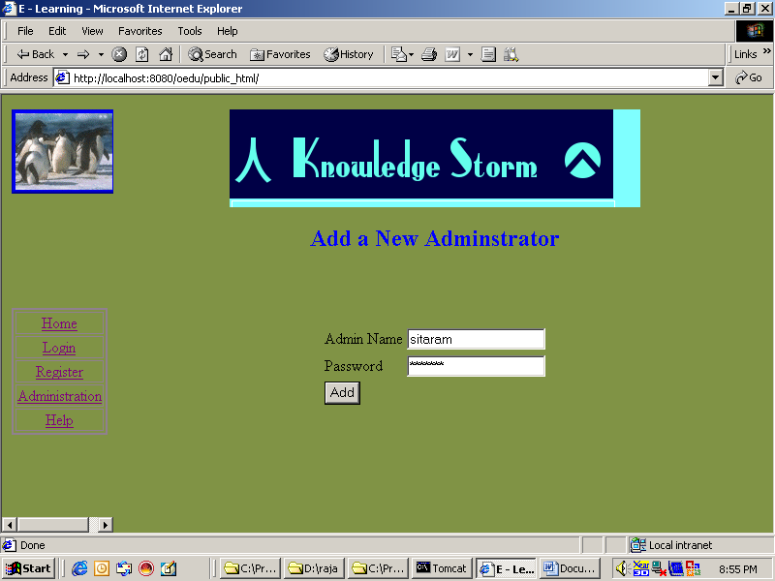

Add new Administrator.
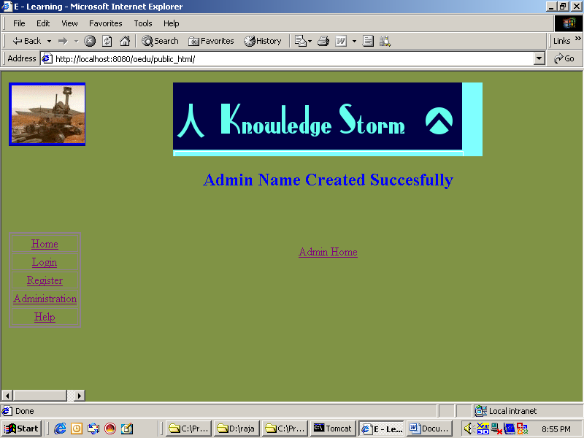

New admin added successfully.

Administration page.
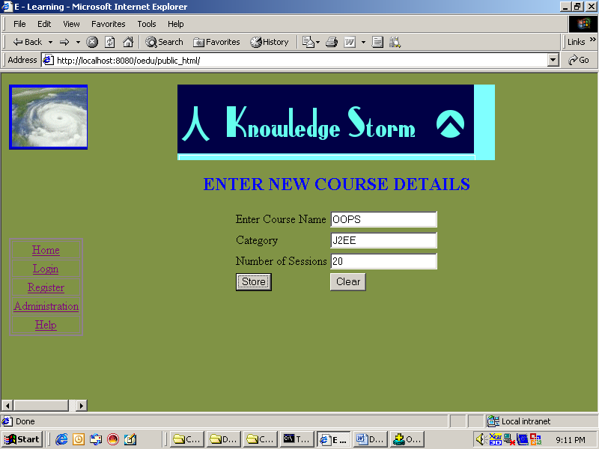

Insert the new course details.
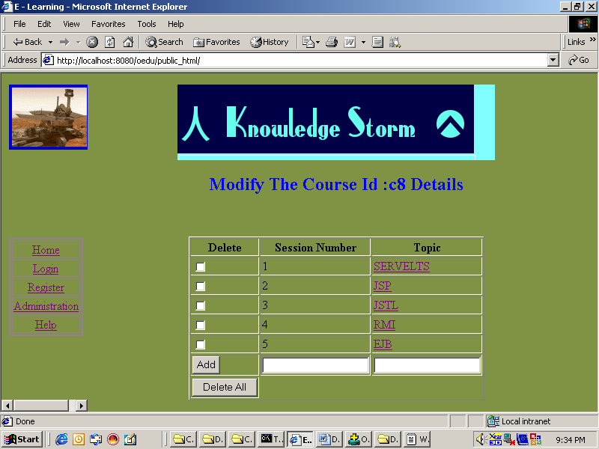

Modify the course details.
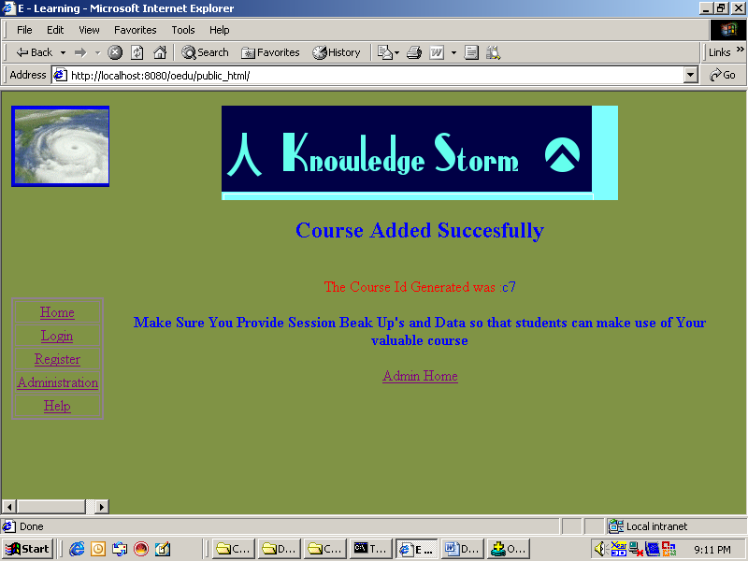

Modified the course details successfully.
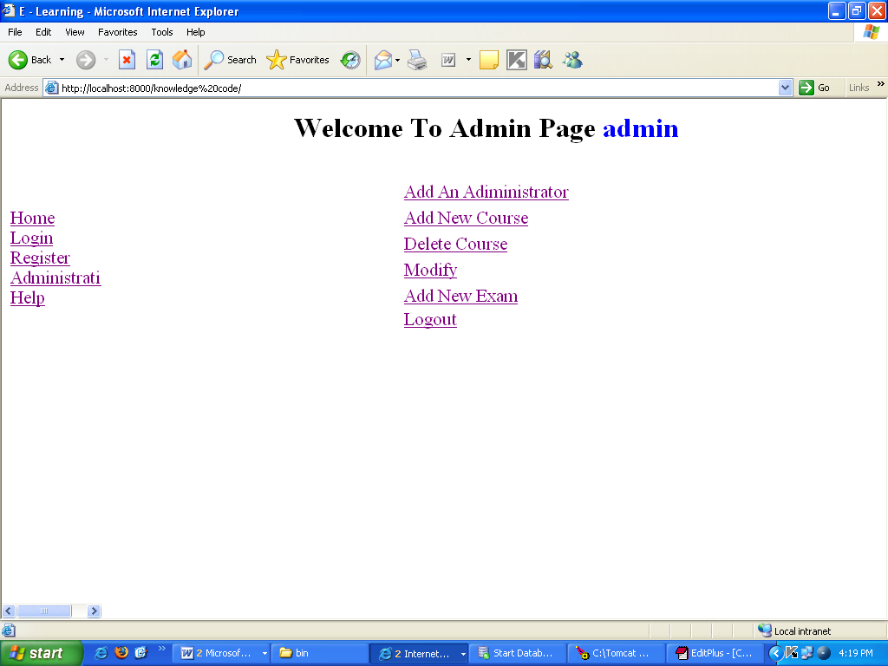

Administrators page details.
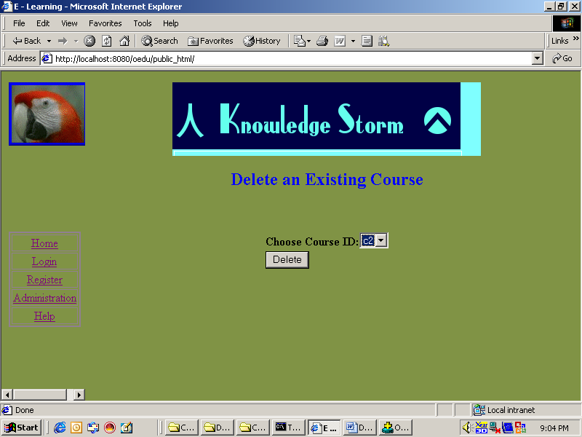

Delete the existing courses.

Administrators page details
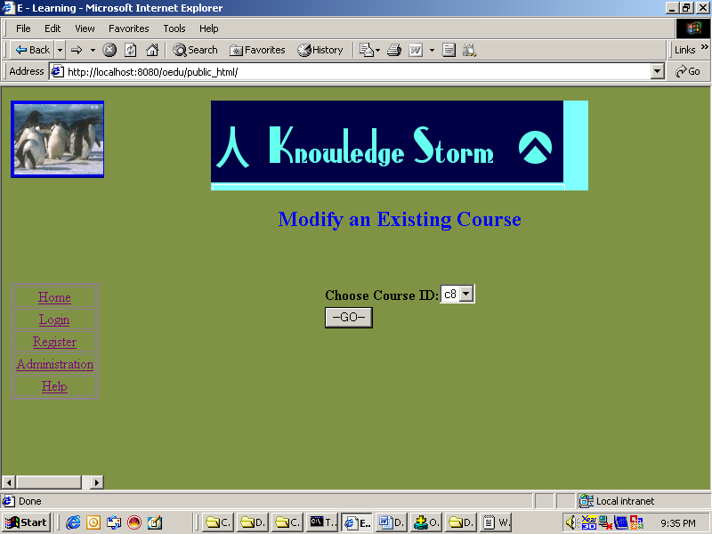

Modify the existing courses.
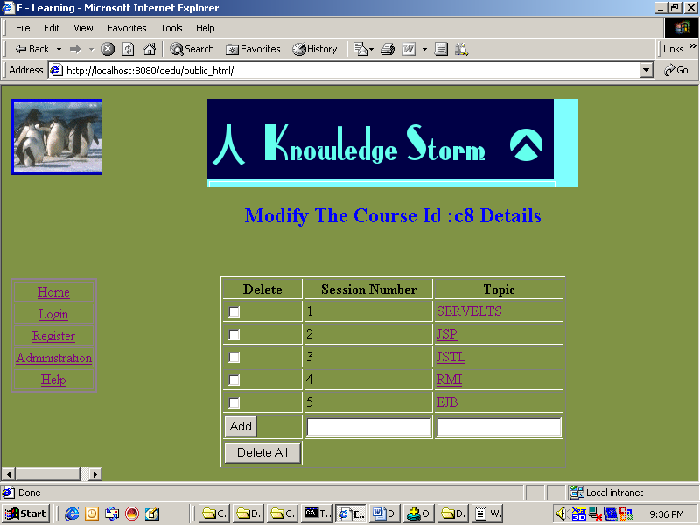

Modify the courses

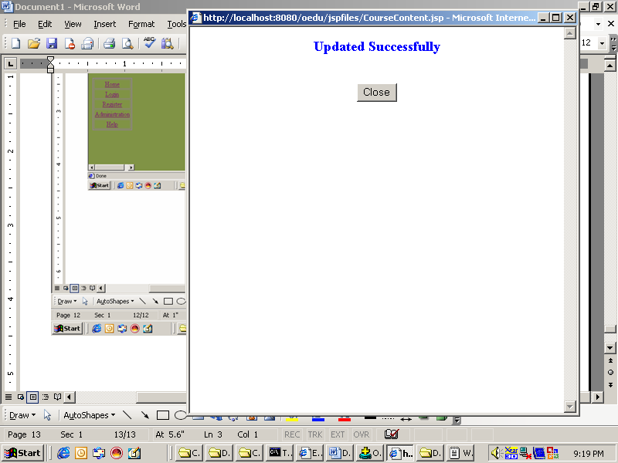

(Deleting the courses)

Administrators page details
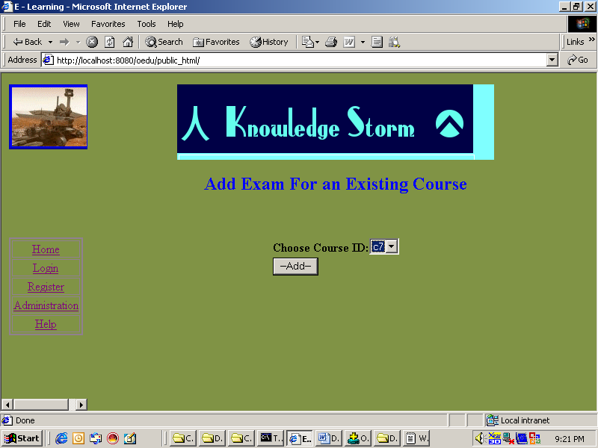

Add exam for existing courses.
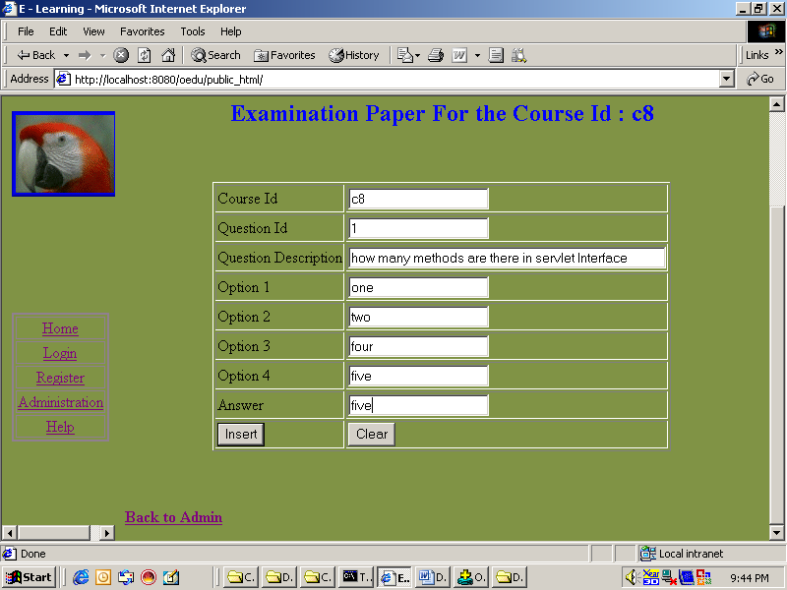

Examination paper for the course id

Administrators page details
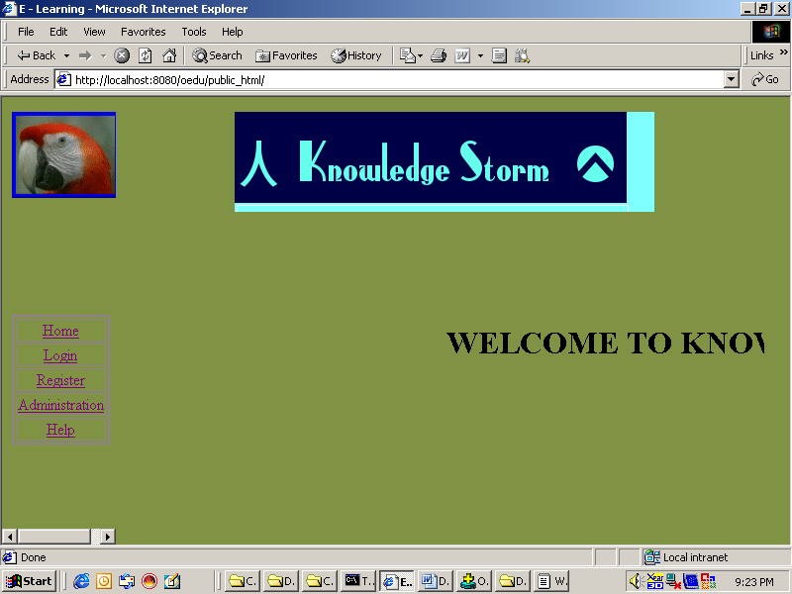

Welcome page of knowledge storm.
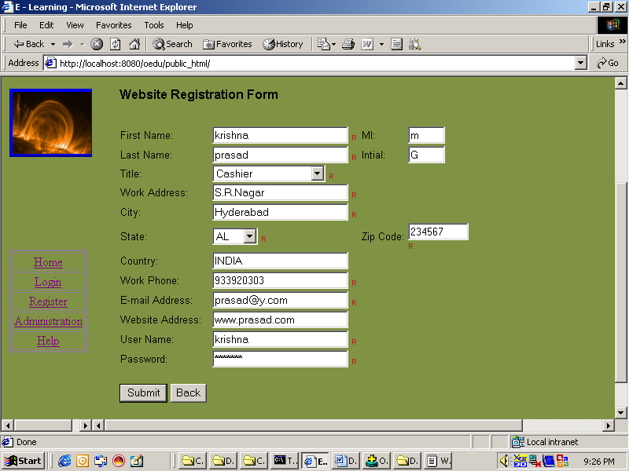

Website registration form.
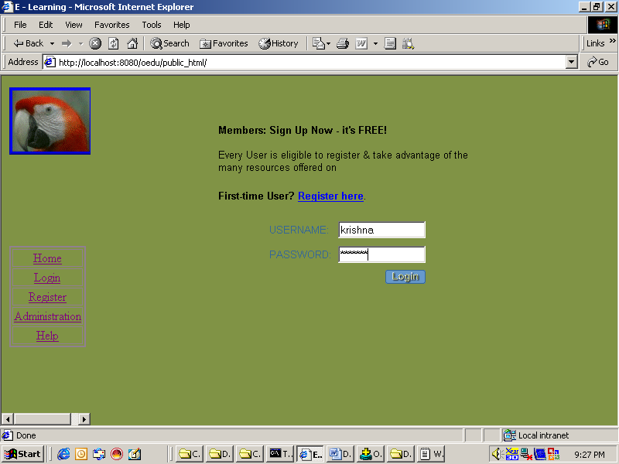

User login page.
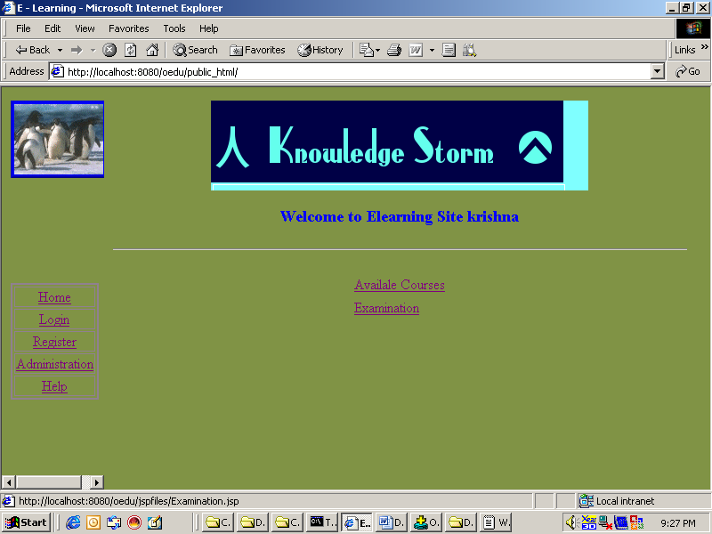

Welcome to Elearning portal page.

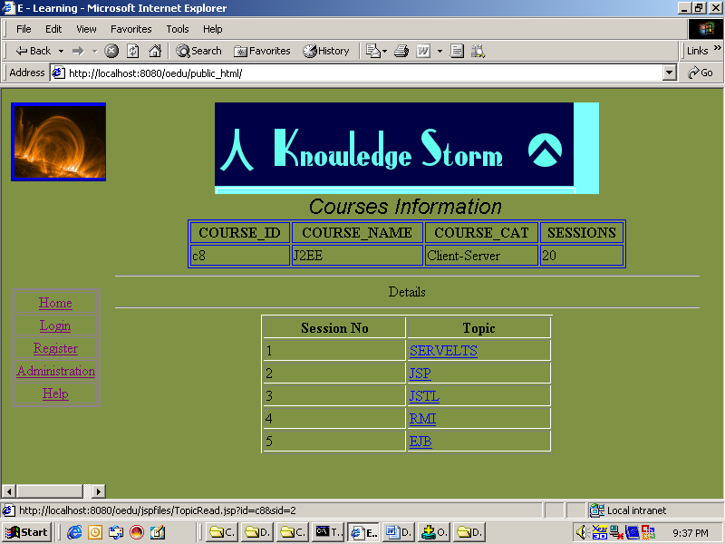

Course details including topics.
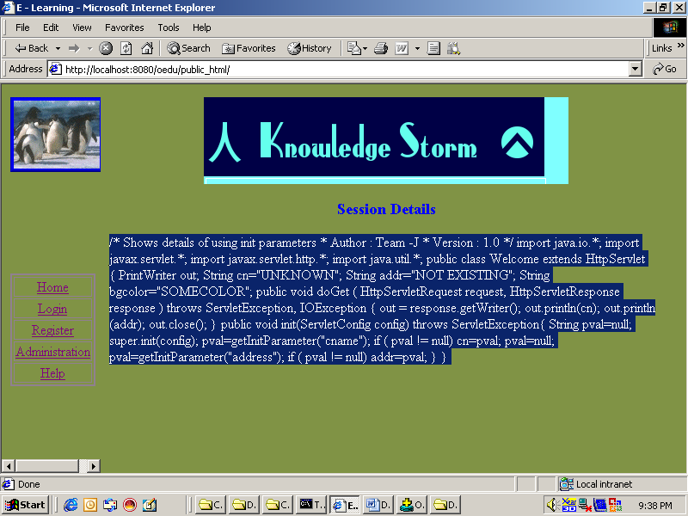

Session details page.
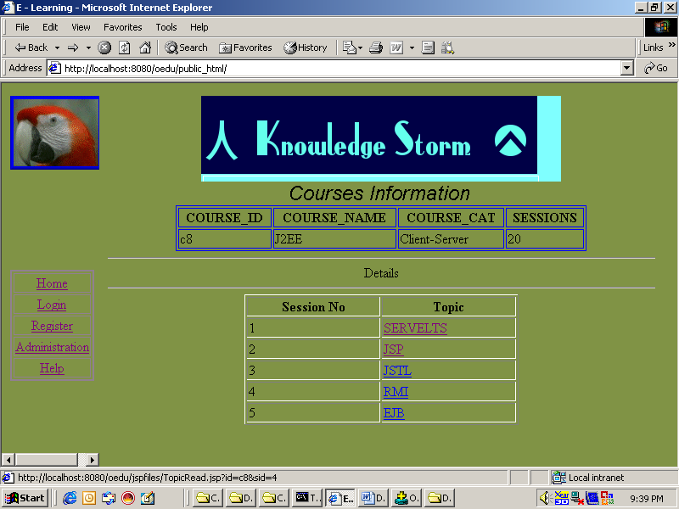

Course details to select the each topic
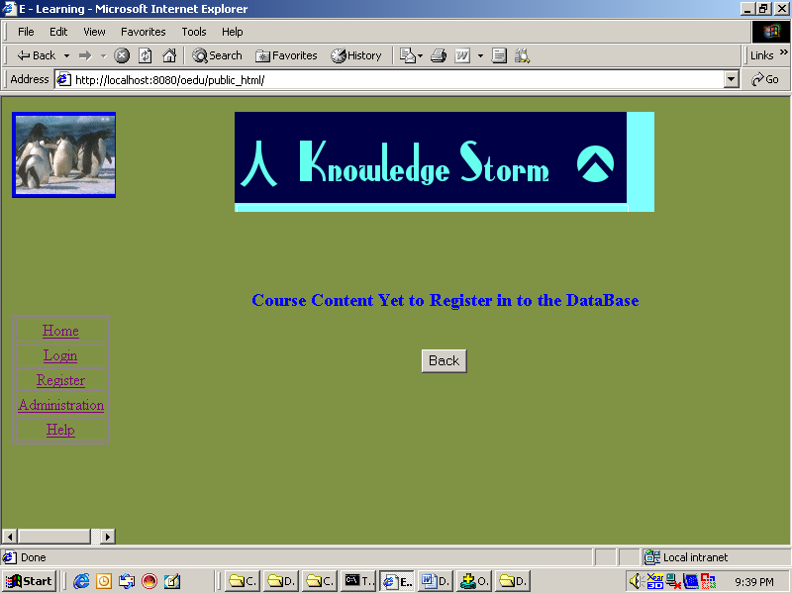

Course content yet to register in the database.
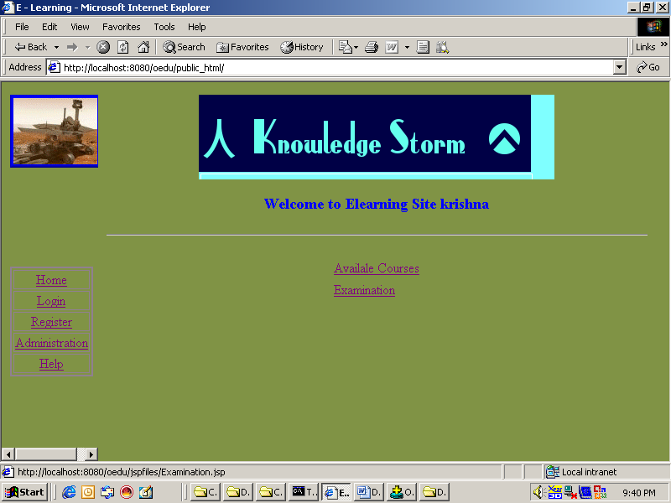

Welcome user page.

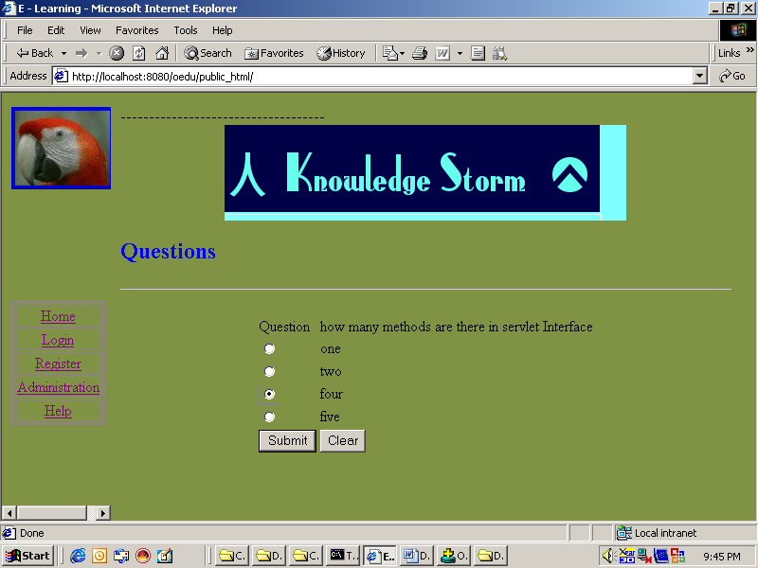

Adding question in the exam page.
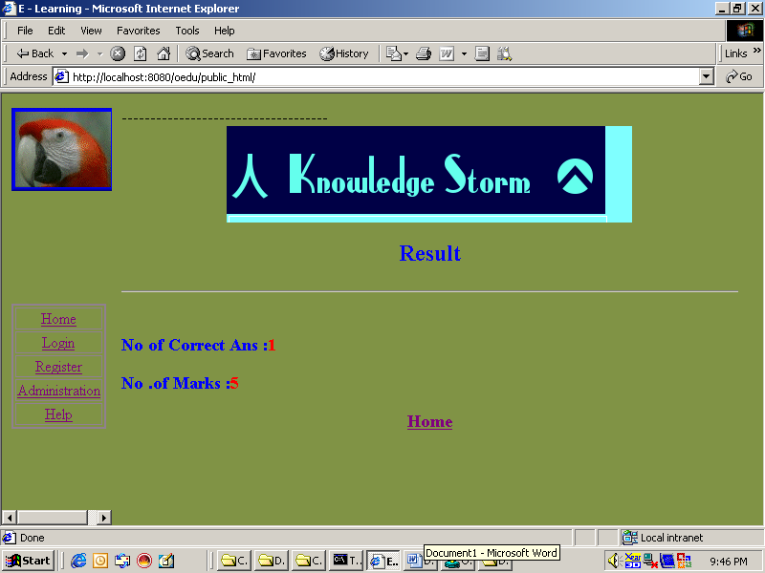

Result set page.

Administrators page details
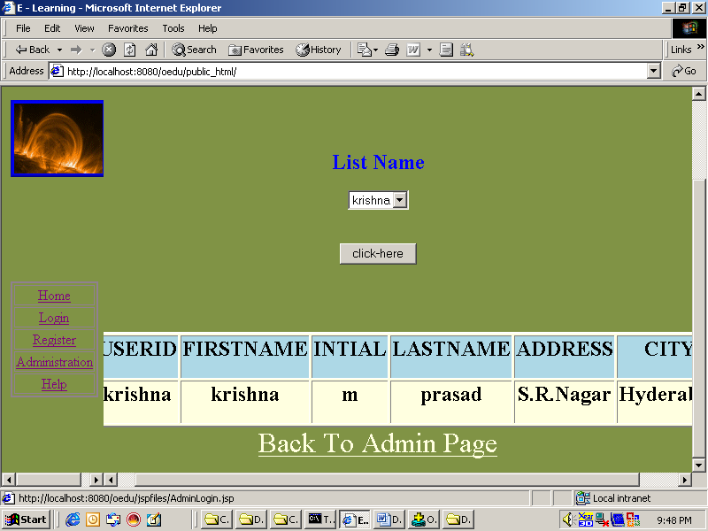

User details page.
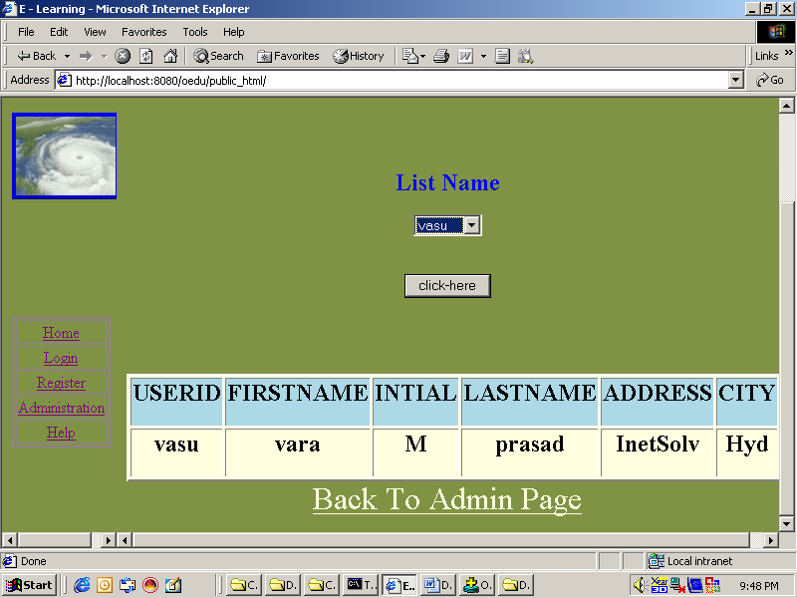

Admin details page.
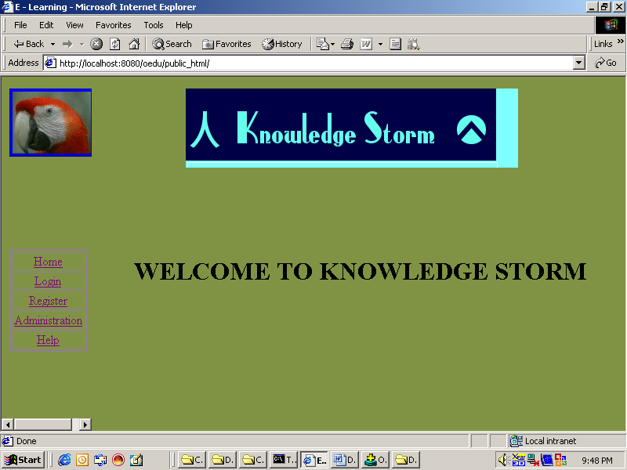

Welcome page of knowledge storm.

Conclusion:

This project has designed and developed for how to achieve the high-level goal of the organizations. This project point to an intervention that will balance the conflicting needs of different stakeholders the means IT versus HR, participants versus managers, budget versus vendor costs and so on. Organizations implementing knowledge storm projects programs need to expand the usual needs assessment process by creating a high-level requirements document that includes

The Knowledgestorm project provides the macro organizational objectives and micro targets and populations objects.

REFERENCE BOOKS

References for the Project Development Were Taken From the following Books and Web Sites.
Oracle
PL/SQL Programming by Scott Urman
SQL complete reference by Livion
JAVA Technologies
JAVA Complete Reference
Java Script Programming by Yehuda Shiran
Mastering JAVA Security
JAVA2 Networking by Pistoria
JAVA Security by Scotl oaks
Head First EJB Sierra Bates
J2EE Professional by Shadab siddiqui
JAVA server pages by Larne Pekowsley
JAVA Server pages by Nick Todd
HTML
HTML Black Book by Holzner
JDBC
Java Database Programming with JDBC by Patel moss.
Software Engineering by Roger Pressman

